**DESIGN AND IMPLEMENTATION OF HAND GESTURE CONTROLLED ROBOT USING ARDUINO**

A Report submitted in partial fulfilment of the requirements for the Degree of

**Bachelor of Technology**

in

**Computer Science and Engineering (Internet of Things)**

by

**G Kalyan Sai Goud**

**Rajam Pavan Kumar**

**Balthu Varshith**

**2111CS050105**

**2111CS050092**

**2111CS050087**

Under the esteemed guidance of

**M. Ravi Kumar**

**Assistant professor**

**Department of Computer Science and Engineering (Internet of Things)**

**School of Engineering**

**MALLA REDDY UNIVERSITY**

Maisammaguda, Dulapally, Hyderabad, Telangana 500100

**2025**

**DESIGN AND IMPLEMENTATION OF HAND GESTURE CONTROLLED ROBOT USING ARDUINO**

A Report submitted in partial fulfilment of the requirements for the Degree of

**Bachelor of Technology**

in

**Computer Science and Engineering (Internet of Things)**

by

**G Kalyan Sai Goud**

**Rajam Pavan Kumar**

**Balthu Varshith**

**2111CS050105**

**2111CS050092**

**2111CS050087**

Under the esteemed guidance of

**M. Ravi Kumar**

**Assistant professor**

**Department of Computer Science and Engineering (Internet of Things)**

**School of Engineering**

**MALLA REDDY UNIVERSITY**

Maisammaguda, Dulapally, Hyderabad, Telangana 500100

**2025**

 **Department of Computer Science and Engineering (Internet Of Things)**

**CERTIFICATE**

This is to certify that the project report entitled “**HAND GESTURE CONTROLLED ROBOT USING ARDUINO”**, submitted by **G. Kalyan Sai Goud (2111CS050105), Balthu Varshith (2111CS050087), Rajam Pavan Yadav (2111CS050092).** towards the partial fulfillment for the award of Bachelor’s Degree in Computer Science and Engineering – Internet of Things from the Department of Internet of Things, Malla Reddy University, Hyderabad, is a record of bonafide work done by him/ her. The results embodied in the work are not submitted to any other University or Institute for award of any degree or diploma.

**Internal Guide**

Mr. M. Ravi Kumar

Assistant Professor

**Head of the department**

Dr . G . Anand Kumar

CSE(Cyber Security & IoT)

**External Examiner**

**DECLARATION**

We hereby declare that the project report entitled “**HAND GESTURE CONTROLLED ROBOT USING ARDUINO**” has been carried out by us and this work has been submitted to the **Department of Computer Science and Engineering (Internet of Things), Malla Reddy University**, Hyderabad in partial fulfilment of the requirements for the award of degree of Bachelor of Technology. We further declare that this project work has not been submitted in full or part for the award of any other degree in any other educational institutions.

Place:

Date:

G. Kalyan Sai Goud 2111CS050105

Balthu Varshith 2111CS050087

Rajam Pavan Yadav 2111CS050092

**ACKNOWLEDGEMENT**

We extend our sincere gratitude to all those who have contributed to the completion of this project report. Firstly, We would like to extend our gratitude to **Dr. V. S. K Reddy, Vice-Chancellor**, for his visionary leadership and unwavering commitment to academic excellence.

We would also like to express my deepest appreciation to our project guide **M. Ravi Kumar Assistant Professor**, whose invaluable guidance, insightful feedback, and unwavering support have been instrumental throughout the course of this project for successful outcomes.

We extend our gratitude to **Dr. G. Latha, PRC-convenor,** for giving valuable inputs and timely guidelines to improve the quality of our project through a critical review process. We thank our project coordinator **Dr. B. Nageshwar Rao,** for his timely support.

We are also grateful to **Dr. G. Anand Kumar, Head of the Department of Internet of Things,** for providing us with the necessary resources and facilities to carry out this project

We are deeply indebted to all of them for their support, encouragement, and guidance, without which this project would not have been possible.

G. Kalyan Sai Goud 2111CS050105

Balthu Varshith 2111CS050087

Rajam Pavan Yadav 2111CS050092

**ABSTRACT**

Hand gesture-controlled robots represent a significant advancement in human-computer interaction, enabling intuitive and contactless control of robotic systems. This project focuses on designing and developing a Hand Gesture Controlled Robot using Arduino, utilizing an MPU6050 accelerometer and nRF24L01 transceivers for seamless communication between the user's hand gestures and the robot's movement. The system consists of two primary modules: the transmitter module, which captures hand motion through an Arduino Nano and MPU6050 sensor, and the receiver module, which interprets the signals via an Arduino Uno and controls the robot's movement using motor drivers.The robot responds to predefined gestures, enabling directional movement such as forward, backward, left, and right turns. The wireless communication between the transmitter and receiver ensures smooth and real-time execution of commands. The project integrates low-power, cost-effective components while maintaining a high level of accuracy and responsiveness.This system can be further extended to applications such as assistive robotics for disabled individuals, industrial automation, and remote-controlled exploration robots. Future improvements may include machine learning integration for adaptive gesture recognition and expanding the gesture set for more complex interactions. This project showcases an innovative, user-friendly, and efficient approach to robotic control using gesture-based technology.

**INDEX**

|  |  |
| --- | --- |
| **Content** | **Page No.** |
| **1. Introduction** | 1-5 |
| 1.1 Problem Definition & Description | 2 |
| 1.2 Aim and Objectives of the Project | 3 |
| 1.3 Scope of the Project | 4 |
| **2. System Analysis** | 6-26 |
| **2.1 Existing System Analysis** | 6 |
| 2.1.1 Background & Literature Survey | 7 |
| 2.1.2 Limitations of Existing System | 8 |
| **2.2 Proposed System Analysis** | 9 |
| 2.2.1 Advantages of Proposed System | 9 |
| **2.3 Software & Hardware Requirements** | 10 |
| 2.3.1 Software Requirements | 10-12 |
| 2.3.2 Hardware Requirements | 13-23 |
| **2.4 Feasibility Study** | 24-31 |
| 2.4.1 Technical Feasibility | 24 |
| 2.4.2 Robustness & Reliability | 25 |
| 2.4.3 Economic Feasibility | 26 |
| **3. Architectural Design** | 27-37 |
| **3.1 Modules Design** | 27 |
| 3.1.1 User Interface Module | 27 |
| 3.1.2 Wireless Communication Module | 28 |
| 3.1.3 Robot Control Module | 28 |
| **3.2 Methodology & Algorithm Design** | 30 |
| 3.2.1 Gesture Recognition Algorithm | 30 |
| 3.2.2 Motor Control Algorithm | 32 |
| **3.3 Project Architecture** | 33 |
| 3.3.1 Architectural Diagram | 33 |
| 3.3.2 Deployment Diagram | 34 |
| 3.3.3 Class Diagram | 35 |
| 3.3.4 Use Case Diagram | 36 |
| 3.3.5 Sequence Diagram | 36 |
| 3.3.5 Activity Diagram | 37 |
| **4. Implementation & Testing** | 38-47 |
| **4.1 Coding Blocks** | 38 |
| 4.1.1 Transmitter Code | 38 |
| 4.1.2 Receiver Code | 41 |
| **4.2 Test Case Study** | 44 |
| 4.2.1 Unit Testing | 44 |
| 4.2.2 Integration Testing | 45 |
| 4.2.3 Sample Test Cases | 46 |
| **4.3 Circuit Diagram & Connections** | 47 |
| **5. Results** | 48-54 |
| 5.1 Resulting Screens | 48 |
| 5.1.1 Transmitter Unit | 48 |
| 5.1.2 Receiver Unit | 48 |
| 5.2 Resulting Tables | 51 |
| 5.2.1 Gesture Accuracy Rate | 51 |
| 5.2.2 Response Time Analysis | 52 |
| **6. Conclusions & Future Scope** | 53 |
| 6.1 Conclusions | 53 |
| 6.2 Future Scope | 54 |
| Bibliography | 55 |
| Paper Publication | 57-60 |
| Github Link: <https://github.com/kalyansai15> |  |

**LIST OF FIGURES**

| **Content** | | **Page Number** |
| --- | --- | --- |
| Fig 3.1.1 | Transmitter Side - Hand Module | 27 |
| Fig 3.1.2 | Receiver Side - Robot Module | 28 |
| Fig 3.2.1 | Flow Chart | 30 |
| Fig 3.2.2 | Five different hand gestures for each control command | 32 |
| Fig 3.3.1 | Architecture Diagram | 33 |
| Fig 3.3.2 | Data Flow Diagram | 34 |
| Fig 3.3.3 | Class Diagram | 35 |
| Fig 3.3.4 | Use Case Diagram | 36 |
| Fig 3.3.5 | Sequence Diagram | 36 |
| Fig 3.3.6 | Activity Diagram | 37 |
| Fig 4.3.1 | Receiver Side - Robot Module Circuit | 47 |
| Fig 4.3.2 | Transmitter Side - Hand Module | 47 |
| Fig 5.1 | Transmitter Unit (TX) -- Hand Module | 48 |
| Fig 5.2 | Receiver Unit (RX) -- Robot Module | 48 |
| Fig 5.3 | Stop Gesture | 49 |
| Fig 5.4 | Forward Gesture | 49 |
| Fig 5.5 | Backward Gesture | 50 |
| Fig 5.6 | Left Gesture | 50 |
| Fig 5.7 | Right Gesture | 51 |

**LIST OF TABLES**

| **Content** | | **Page Number** |
| --- | --- | --- |
| Table 5.2.1 | Gesture Accuracy Rate | 51 |
| Table 5.2.2 | Response Time Analysis | 51 |
| Table 5.2.3 | Range & Stability of Wireless Communication | 52 |
| Sample Test Cases | | 46 |

**CHAPTER - 1**

**INTRODUCTION**

Nowadays, robotics are becoming one of the most advanced in the field of technology. A Robot is an electro-mechanical system that is operated by a computer program. Robots can be autonomous or semi-autonomous. An autonomous robot is not controlled by human and acts on its own decision by sensing its environment. Majority of the industrial robots are autonomous as they are required to operate at high speed and with great accuracy. But some applications require semi-autonomous or human controlled robots. Some of the most commonly used control systems are voice recognition, tactile or touch controlled and motion controlled. A Gesture Controlled robot is a kind of robot which can be controlled by your hand gestures not by old buttons. You just need to wear a small transmitting device in your hand which included an acceleration meter. This will transmit an appropriate command to the robot so that it can do whatever we want. The transmitting device included Arduino Nano, Accelerometer(MPU6050), RF Transmitter, HT-12E Encoder. At the receiving end an RF Receiver module receives the encoded data and decode it by and decoder IC(HT12D). This data is then processed by an Arduino UNO and finally our motor driver to control the motor's. Now it’s time to break the task in different module's to make the task easy and simple any project become easy or error free if it is done in different modules. As our project is already divided into two different part transmitter and receiver. The applications of robotics mainly involve in automobiles, medical, construction, defense and also used as a fire fighting robot to help the people from the fire accident. But, controlling the robot with a remote or a switch is quite complicated. So, a new project is developed that is, an accelerometer-based gesture control robot. The main goal of this project is to control the movement of the robot with hand gesture using accelerometer. The robot is usually an electro-mechanical machine that can perform tasks automatically. Some robots require some degree of guidance, which may be done using a remote control or with a computer interface. Robots can be autonomous, semi-autonomous or remotely controlled. Robots have evolved so much and are capable of mimicking humans that they seem to have a mind of their own.

* 1. **Problem Definition & Description**

Traditional robotic control methods, such as joysticks, keyboards, and touchscreens, have long been the standard for human-machine interaction. However, these methods come with significant limitations that hinder their effectiveness and accessibility. One of the primary issues is their dependency on physical input devices, which require precise motor skills and direct physical contact. This makes them unsuitable for individuals with physical disabilities or those operating in environments where hands-free interaction is essential. For example, a person with limited hand mobility may struggle to use a joystick, while a factory worker in a hazardous environment may find it impractical to operate a keyboard or touchscreen.

Another critical limitation of traditional control methods is their lack of intuitiveness and natural interaction. Devices like joysticks and keyboards often require extensive training and practice to master, creating a steep learning curve for users. This complexity can be a barrier to adoption, particularly in applications where ease of use is paramount, such as assistive technology or consumer robotics. Additionally, voice-controlled systems, while hands-free, are prone to errors in noisy environments and may not be suitable for users with speech impairments. These shortcomings highlight the need for a more inclusive, intuitive, and versatile approach to robotic control. The gap in current technology lies in the absence of a control method that combines real-time responsiveness, simplicity, and accessibility. Existing systems often fail to provide a seamless user experience, particularly for individuals with disabilities or in specialized environments. This is where gesture-based control systems can make a significant impact. By leveraging natural hand movements, gesture control eliminates the need for physical input devices, making it more accessible and user-friendly. However, many existing gesture-controlled systems face challenges such as latency, limited accuracy, and high computational requirements, which restrict their real-world applicability.

This project aims to bridge these gaps by developing a gesture-controlled robotic system that prioritizes real-time responsiveness, reduces complexity, and enhances user interaction. The proposed system will focus on improving the accuracy and speed of gesture recognition, ensuring that users can control robotic devices with minimal delay and maximum precision. Additionally, the system will be designed to be intuitive and easy to use, requiring little to no training for operation. By addressing these challenges, the project seeks to create a more inclusive and efficient solution for human-machine interaction, particularly in applications such as assistive technology, industrial automation, and remote operations.

* 1. **Objectives of the Project**

The primary goal of this project is to design and develop a **wireless hand gesture-controlled robot** that leverages cutting-edge hardware and software technologies to create an intuitive, accessible, and efficient human-machine interaction system. By combining Arduino, MPU6050 sensors, and nRF24L01 transceivers, the project aims to bridge the gap between traditional robotic control methods and modern, user-friendly interfaces. The specific objectives of the project are outlined below:

**1. Design and Develop a Wireless Hand Gesture-Controlled Robot**

The project focuses on building a functional robotic system that can be controlled wirelessly using hand gestures. The system will consist of two main modules:

* **Transmitter Module**: A hand-worn device equipped with an MPU6050 sensor to capture hand movements and an nRF24L01 transceiver to send gesture data wirelessly.
* **Receiver Module**: A robot equipped with an Arduino microcontroller and an nRF24L01 transceiver to receive and interpret gesture commands, enabling real-time navigation.

**2. Enable Intuitive Real-Time Robot Navigation**

The system will be programmed to recognize and respond to a set of **predefined hand gestures**, such as tilting the hand forward, backward, left, or right, to control the robot’s movement in corresponding directions. The goal is to ensure **real-time responsiveness** and **high accuracy** in gesture recognition, allowing users to control the robot seamlessly and without noticeable delays.

**3. Establish Reliable and Efficient Wireless Communication**

A key objective is to implement a robust wireless communication system using **nRF24L01 transceivers**. This system will ensure stable and low-latency data transmission between the transmitter (hand module) and the receiver (robot module), even in environments with moderate interference. The communication protocol will be optimized for efficiency to minimize power consumption and maximize reliability.

**4. Improve Accessibility for Individuals with Physical Disabilities**

One of the core motivations of this project is to create a **contactless control interface** that enhances accessibility for individuals with physical disabilities. By eliminating the need for physical input devices like joysticks or keyboards, the gesture-controlled robot provides a more inclusive and user-friendly alternative, empowering users with limited mobility to interact with robotic systems independently.

* 1. **SCOPE OF THE PROJECT**

The wireless hand gesture-controlled robot developed in this project has a wide range of applications across various domains, demonstrating its versatility and potential to transform human-machine interaction. By leveraging intuitive gesture-based control, the system can be deployed in environments where traditional input methods are impractical, unsafe, or inaccessible. Below are the key areas where this system can be applied, along with future expansion possibilities:

**Applications of the System**

1. **Industrial Automation**

In manufacturing and logistics, the gesture-controlled robot can be used to operate machinery or navigate automated guided vehicles (AGVs) in hazardous environments. By enabling hands-free control, the system enhances worker safety and operational efficiency, particularly in settings where physical contact with equipment is risky or restricted.

1. **Assistive Devices**

The system is particularly impactful in the field of assistive technology, where it can empower individuals with physical disabilities to perform daily tasks independently. For example, a gesture-controlled robotic arm can assist users with limited mobility in eating, drinking, or manipulating objects, significantly improving their quality of life.

1. **Gaming and Entertainment**

The gesture-controlled robot can enhance immersive experiences in gaming and virtual reality (VR). By allowing users to interact with digital environments using natural hand movements, the system provides a more engaging and intuitive gaming experience.

1. **Smart Home Systems**

The system can be integrated into smart home environments to control appliances, lighting, or security systems through gestures. This adds a layer of convenience and accessibility, particularly for elderly or disabled individuals who may struggle with traditional remote controls or touchscreens.

1. **Remote Exploration**

In scenarios such as space exploration, underwater exploration, or disaster response, the gesture-controlled robot can enable operators to navigate and manipulate robots from a distance. This reduces the need for direct physical intervention in dangerous or inaccessible areas, enhancing safety and operational efficiency.

**Future Expansion Possibilities**

The project lays the foundation for several future enhancements that can further expand the capabilities and applications of the system:

1. **AI-Based Gesture Learning**

Incorporating machine learning algorithms can improve the system’s ability to recognize and adapt to new gestures over time. This would enable more sophisticated and personalized interactions, enhancing the system’s usability and accuracy.

1. **IoT Connectivity**

Integrating the system with the Internet of Things (IoT) can enable seamless communication with other smart devices and systems. For example, the robot could be programmed to interact with smart home devices, industrial sensors, or healthcare monitoring systems, opening up new possibilities for automation and remote control.

1. **Advanced Navigation and Autonomy**

Future iterations of the system could incorporate AI-driven navigation algorithms, enabling the robot to perform tasks autonomously while still responding to gesture-based commands when needed. This would be particularly useful in complex environments like warehouses or hospitals.

**CHAPTER - 2**

**SYSTEM ANALYSIS**

This section provides a comprehensive overview of existing technologies, research studies, and similar projects in the field of gesture-controlled robotics. By analyzing the strengths and limitations of current solutions, this survey highlights the need for an affordable, portable, and efficient gesture-based control system. It also explores relevant research studies and technologies that form the foundation of this project.

**2.1 EXISTING SYSTEM**

1. **Joystick-Based Control Systems**

Joysticks have been widely used for controlling robots and machinery due to their reliability and ease of implementation. They provide precise control over movement and are commonly used in applications such as gaming, industrial automation, and remote-controlled vehicles.

1. **Voice-Controlled Robots**

Voice control systems enable hands-free operation by interpreting spoken commands. These systems are popular in smart home devices, assistive technology, and consumer electronics, offering a convenient alternative to physical input devices.

1. **Gesture-Based Solutions Using Cameras**

Camera-based gesture recognition systems use computer vision algorithms to detect and interpret hand movements. These systems are highly accurate and capable of recognizing a wide range of gestures, making them suitable for applications like gaming, virtual reality, and industrial automation.

**2.1.1 BACKGROUND AND LITERATURE SURVEY**

[1] This paper discusses a proposed hand gesture-based control design for mobile robots. Mobile robots can move in response to hand gestures that convey control signals. Image processing, image counter processing, and other techniques are used to recognize gestures. The control of a mobile robot is based on information that has been recognized and decoded.

[2] The user's gestures direct the movement of the mobile robot in this project. This model consists of transmitter unit with PIC Microcontroller for recognition of gestures. The instructions will be followed by the receiver unit (mobile robot) with PIC Microcontroller. This system was created at a low cost and with a high level of efficiency.

[3] The goal of this project is to use hand gestures to operate a mobile robot. To do this, the recorded hand pictures are processed using a circular Hough transform-based method to determine the appropriate targets. Then, to regulate the robot's motion, control signals are supplied to the receiver unit.

[4] This paper describes how humans can communicate with robots using basic hand gestures. This can be done using a Leap motion sensor. We suppose that the robot is capable of emotional interaction in this scenario. This study helps us to understand how human can interact with a robot using effective hand gestures.

[5] In this paper, they show a hand-gesture-based control interface for navigating a car-robot. A three-axis accelerometer records the user's hand motions. Any form of connection is used to provide data wirelessly to a microcontroller. The received signals are then converted into one of six car-robot navigational control commands.

[6] This paper presents a method of controlling an automata with hand gestures using the Arduino Lilypad. A motion device attached on the hand gloves is used to control the projected model. This style's major goal is to control the robot victimisation hand gesture.

[7] The main purpose of this project is to control the robotic arm's movement using an accelerometer/gyroscope-based gesture controller, that's far more convenient than using a joystick or keyboard. This paper's main contribution is the development of a simple and effective object detection system on the robot's physical model. The experimental results are used to assess the suggested object detection algorithm and gesture controller.

[8] In this paper, hand gestures are used to operate a robot. They proposed a new user hand detection method, as well as hand gesture detection that relies on the robot's camera to recognize the hand in successive frames. They were able to get the robot to follow the detected hand. In future study subjects, the detection rate of the hand will be raised.

**2.1.2 LIMITATIONS OF EXISTING SYSTEM**

1. **Joystick-Based Control Systems**
   * **Physical Handling**: Requires direct physical contact, making it unsuitable for individuals with disabilities or in environments where hands-free operation is necessary.
   * **Lack of Intuitiveness**: Often requires training and practice, creating a barrier for novice users.
   * **Limited Accessibility**: The need for fine motor skills restricts its use in applications requiring inclusivity and ease of use.
2. **Voice-Controlled Robots**
   * **Noise Interference**: Prone to errors in noisy environments, reducing reliability.
   * **Speech Impairments**: Inaccessible or challenging for users with speech difficulties.
   * **Limited Precision**: Lacks the expressiveness and precision of physical gestures, making it unsuitable for tasks requiring nuanced control.
3. **Gesture-Based Solutions Using Cameras**
   * **High Cost**: Requires expensive hardware and computational resources.
   * **Field of View**: Depends on a clear and unobstructed line of sight, which may not always be feasible.
   * **Portability Issues**: Bulky and less portable due to the need for cameras and additional processing units.

**2.2 PROPOSED SYSTEM**

The proposed system is a **wireless hand gesture-controlled robot** that uses an **MPU6050 sensor** for motion detection and an **Arduino microcontroller** for processing. The system consists of two main modules:

* **Transmitter Module**: A hand-worn device equipped with an MPU6050 sensor to capture hand movements and an nRF24L01 transceiver to send gesture data wirelessly.
* **Receiver Module**: A robot equipped with an Arduino microcontroller and an nRF24L01 transceiver to receive and interpret gesture commands, enabling real-time navigation.

**2.2.1 ADVANTAGES OF PROPOSED SYSTEM**

1. **Portability**  
   The compact design of the MPU6050 sensor and nRF24L01 transceiver ensures that the system is lightweight and easy to use, making it suitable for mobile and remote applications.
2. **Camera-Free Operation**

Unlike camera-based systems, the proposed approach does not require a clear field of view, making it more versatile and practical for real-world use in environments with obstructions or limited space.

1. **Intuitive and User-Friendly**

The use of hand gestures provides a natural and intuitive interface, reducing the learning curve and making the system accessible to users with varying levels of technical expertise.

1. **Real-Time Responsiveness**

The system is designed to provide low-latency communication and high accuracy in gesture recognition, ensuring seamless and real-time control of the robot.

1. **Inclusivity**  
   By eliminating the need for physical input devices, the system enhances accessibility for individuals with physical disabilities, enabling them to interact with robotic systems independently.
2. **Scalability and Future Enhancements**

The proposed system lays the groundwork for future enhancements, such as integrating machine learning for advanced gesture recognition, adding voice control for multimodal interaction, and enabling IoT connectivity for smart automation applications.

1. **Affordability**

The MPU6050 sensor and Arduino platform are cost-effective, making the system accessible for a wide range of applications, including education, research, and small-scale industrial use.

* 1. **Software & Hardware Requirements**
     1. **Software Requirements**

1. **ARDUINO SOFTWARE (IDE):**

The open-source Arduino Software (IDE) makes it easy to write code and upload

it to the board. It runs on Windows, Mac OS X, and Linux. The environment is written in Java and based on Processing and other open-source software. This software can be used with any Arduino board. For latest software: - <https://www.arduino.cc/en/Main/Software>.

* Arduino was born at the Ivrea Interaction Design Institute as an easy tool for fast prototyping, aimed at students with or without a background in electronics and programming.
* Arduino is an open-source prototyping platform based on easy-to use hardware and software.
* Arduino boards can read inputs - light on a sensor, a finger on a button, or a message - and turn it into an output - activating a motor, turning on an LED, publishing something online and many more.
* You can tell your board what to do by sending a set of instructions to the microcontroller on the board.
* To do so you use the Arduino programming language (based on Wiring), and the

Arduino Software (IDE), based on Processing.

* **Inexpensive:** Arduino boards are relatively inexpensive compared to other microcontroller platforms.
* **Cross-platform:** The Arduino Software (IDE) runs on Windows, Macintosh OSX, and Linux operating systems. Most microcontroller systems are limited to Windows.
* **Simple, clear programming environment:** The Arduino Software (IDE) is easy-to-use for beginners, yet flexible enough for advanced users to take advantage of as well.
* **Open source and extensible hardware:**Th**e** plans of the Arduino boards are published under a Creative Commons license, so experienced circuit designers can make their own version of the module, extending it and improving it.
* **Open source and extensible software**: The Arduino software is published as open source tool and the language can be expanded through C++ libraries.

**B. Libraries Used**

The project relies on several Arduino libraries to interface with hardware components and implement key functionalities. Below are the primary libraries used and their roles:

1. **Wire.h (I2C Communication for MPU6050)**  
   The **Wire.h** library is used to facilitate **I2C (Inter-Integrated Circuit)** communication between the Arduino microcontroller and the MPU6050 sensor. The MPU6050 uses I2C to transmit motion data (accelerometer and gyroscope readings) to the Arduino. Key features of the Wire.h library include:
   * **I2C Protocol Implementation**: Simplifies the process of setting up and managing I2C communication.
   * **Data Transmission**: Enables the Arduino to read sensor data from the MPU6050, such as acceleration and angular velocity.
   * **Ease of Integration**: Provides functions like Wire.begin(), Wire.beginTransmission(), and Wire.read() to streamline communication with I2C devices.
2. **RF24.h (nRF24L01 Communication)**  
   The **RF24.h** library is used to manage wireless communication between the transmitter (hand module) and the receiver (robot module) using **nRF24L01 transceivers**. This library is essential for enabling real-time gesture control. Key features of the RF24.h library include:
   * **Wireless Communication**: Implements the nRF24L01's radio frequency (RF) communication protocol, allowing data to be transmitted and received wirelessly.
   * **Low Latency**: Ensures fast and reliable data transmission, which is critical for real-time control applications.
   * **Configurability**: Provides functions to configure the nRF24L01's operating frequency, transmission power, and data rate.
   * **Error Handling**: Includes mechanisms for detecting and handling transmission errors, ensuring robust communication.
3. **Servo.h (If Using Servos)**  
   The **Servo.h** library is used to control servo motors, which may be employed in the robot for tasks such as steering or manipulating objects. This library simplifies the process of controlling servo motors by providing high-level functions. Key features of the Servo.h library include:
   * **Servo Control**: Allows precise control of servo motor angles using functions like servo.attach() and servo.write().
   * **Ease of Use**: Abstracts the complexities of pulse-width modulation (PWM) signal generation, making it easy to integrate servos into the project.
   * **Compatibility**: Works with a wide range of servo motors, ensuring flexibility in hardware selection
     1. **HARDWARE REQUIREMENTS**
4. **ARDUINO UNO**

The Arduino Uno is a microcontroller board based on the ATmega328 (datasheet). It has 14 digital input/output pins (of which 6 can be used as PWM outputs), 6 analog inputs, a 16 MHz ceramic resonator, a USB connection, a power jack, an ICSP header, and a reset button. It contains everything needed to support the microcontroller; simply connect it to a computer with a USB cable or power it with a AC-to-DC adapter or battery to get started.

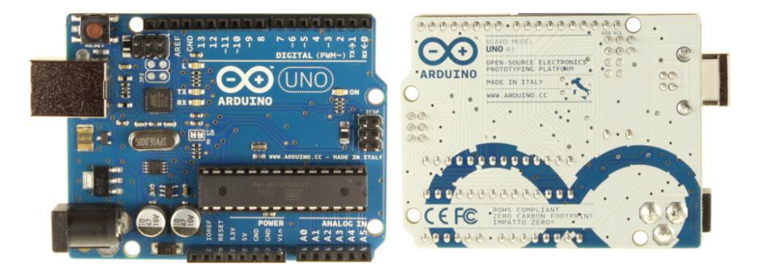The Uno differs from all preceding boards in that it does not use the FTDI USB-to-serial driver chip. Instead, it features the Atmega16U2 (Atmega8U2 up to version R2) programmed as a USB-to-serial converter.

Fig 2.3.9 : Arduino UNO

Revision 2 of the Uno board has a resistor pulling the 8U2 HWB line to ground, making it easier to put into DFU mode.

Revision 3 of the board has the following new features:

• 1.0 pinout: added SDA and SCL pins that are near to the AREF pin and two other new pins placed near to the RESET pin, the IOREF that allow the shields to adapt to the voltage provided from the board. In future, shields will be compatible both with the board that use the AVR, which operate with 5V and with the Arduino Due that operate with 3.3V. The second one is a not connected pin, that is reserved for future purposes.

• Stronger RESET circuit.

• Atmega 16U2 replace the 8U2.

"Uno" means one in Italian and is named to mark the upcoming release of Arduino 1.0. The Uno and version 1.0 will be the reference versions of Arduino, moving forward. The Uno is the latest in a series of USB Arduino boards, and the reference model for the Arduino platform; for a comparison with previous versions, see the index of Arduino boards.

**Powering Arduino UNO:**

The Arduino Uno can be powered via the USB connection or with an external power supply. The power source is selected automatically.

External (non-USB) power can come either from an AC-to-DC adapter (wall-wart) or battery. The adapter can be connected by plugging a 2.1mm center-positive plug into the board's power jack. Leads from a battery can be inserted in the Gnd and Vin pin headers of the POWER connector. The board can operate on an external supply of 6 to 20 volts. If supplied with less than 7V, however, the 5V pin may supply less than five volts and the board may be unstable. If using more than 12V, the voltage regulator may overheat and damage the board. The recommended range is 7 to 12 volts.

The power pins are as follows:

• VIN. The input voltage to the Arduino board when it's using an external power source (as opposed to 5 volts from the USB connection or other regulated power source). You can supply voltage through this pin, or, if supplying voltage via the power jack, access it through this pin.

• 5V.This pin outputs a regulated 5V from the regulator on the board. The board can be supplied with power either from the DC power jack (7 - 12V), the USB connector (5V), or the VIN pin of the board (7-12V). Supplying voltage via the 5V or 3.3V pins bypasses the regulator, and can damage your board. We don't advise it.

• 3V3. A 3.3 volt supply generated by the on-board regulator. Maximum current draw is 50 mA.

• GND. Ground pins.

**Input and Output**

Each of the 14 digital pins on the Uno can be used as an input or output, using pinMode(), digitalWrite(), and digitalRead() functions. They operate at 5 volts. Each pin can provide or receive a maximum of 40 mA and has an internal pull-up resistor (disconnected by default) of 20-50 kOhms. In addition, some pins have specialized functions:

• Serial: 0 (RX) and 1 (TX). Used to receive (RX) and transmit (TX) TTL serial data. These pins are connected to the corresponding pins of the ATmega8U2 USB-to-TTL Serial chip.

• External Interrupts: 2 and 3. These pins can be configured to trigger an interrupt on a low value, a rising or falling edge, or a change in value. See the attachInterrupt() function for details.

• PWM: 3, 5, 6, 9, 10, and 11. Provide 8-bit PWM output with the analogWrite() function.

• SPI: 10 (SS), 11 (MOSI), 12 (MISO), 13 (SCK). These pins support SPI communication using the SPI library.

• LED: 13. There is a built-in LED connected to digital pin 13. When the pin is HIGH value, the LED is on, when the pin is LOW, it's off.

The Uno has 6 analog inputs, labeled A0 through A5, each of which provide 10 bits of resolution (i.e. 1024 different values). By default they measure from ground to 5 volts, though is it possible to change the upper end of their range using the AREF pin and the analogReference() function. Additionally, some pins have specialized functionality:

• TWI: A4 or SDA pin and A5 or SCL pin. Support TWI communication using the Wire library. There are a couple of other pins on the board:

• AREF. Reference voltage for the analog inputs. Used with analogReference().

• Reset. Bring this line LOW to reset the microcontroller. Typically used to add a reset button to shields which block the one on the board. See also the mapping between Arduino pins and ATmega328 ports. The mapping for the Atmega8, 168, and 328 is identical.

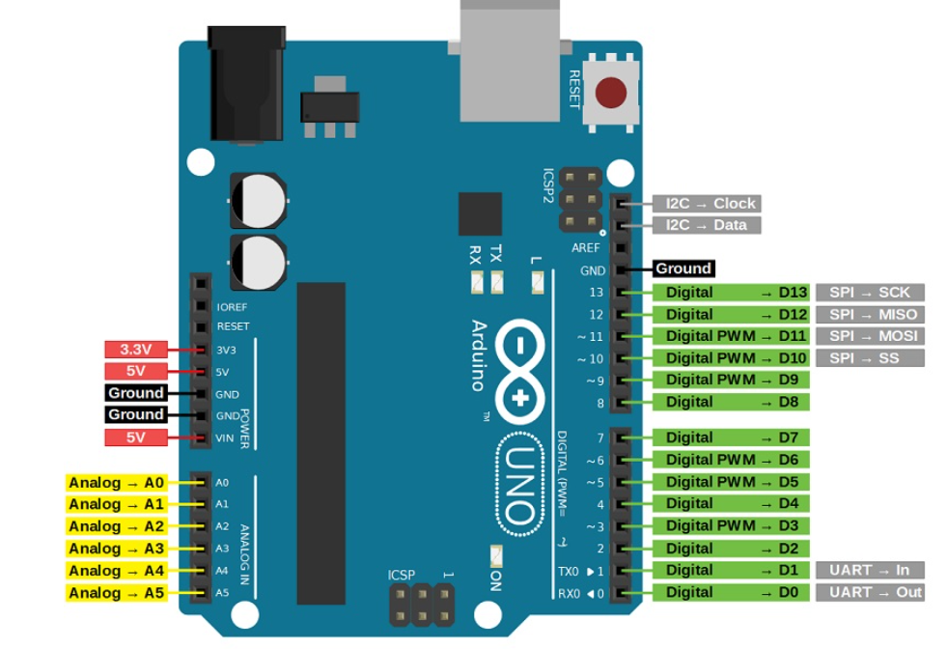**Arduino UNO Pin Configuration:**

Fig 2.3.10 : Pin configuration

| **Pin Category** | **Pin Name** | **Details** |
| --- | --- | --- |
| **Power** | 5V | Provides 5V power to the MPU6050 sensor and nRF24L01 transceiver. |
|  | 3.3V | Provides 3.3V power to the nRF24L01 transceiver (if required). |
|  | GND | Ground connection for all components (MPU6050, nRF24L01, servos, etc.). |
| **Digital I/O** | D2 | Interrupt pin for the MPU6050 sensor (optional, for data-ready interrupts). |
|  | D3 | Servo control pin (if servos are used for robot movement or manipulation). |
|  | D4 | Servo control pin (if multiple servos are used). |
|  | D7 | Chip Enable (CE) pin for the nRF24L01 transceiver. |
|  | D8 | Chip Select (CSN) pin for the nRF24L01 transceiver. |
|  | D11 | MOSI (Master Out Slave In) pin for SPI communication with nRF24L01. |
|  | D12 | MISO (Master In Slave Out) pin for SPI communication with nRF24L01. |
|  | D13 | SCK (Serial Clock) pin for SPI communication with nRF24L01. |
| **Analog Input** | A4 | SDA (Serial Data Line) pin for I2C communication with the MPU6050 sensor. |
|  | A5 | SCL (Serial Clock Line) pin for I2C communication with the MPU6050 sensor. |
| **Communication** | TX (D1) | Serial communication (optional, for debugging or data logging). |
|  | RX (D0) | Serial communication (optional, for debugging or data logging). |

1. **MPU6050 ACCELEROMETER:**

Here the most important component is accelerometer. Accelerometer is a 3 axis acceleration measurement device with +-3g range. This device is made by using polysilicon surface sensor and signal conditioning circuit to measure acceleration. The output of this device is Analog in nature and proportional to the acceleration. This device measures the static acceleration of gravity when we tilt it. And gives an result in form of motion or vibration.

According to the datasheet of adxl335 polysilicon surface-micromachined structure placed on top of silicon wafer. Polysilicon springs suspend the structure over the surface of the wafer and provide a resistance against acceleration forces. Deflection of the structure is measured using a differential capacitor which incorporate independent fixed plates and plates attached to the moving mass. The fixed plates are driven by 180° out-of-phase square waves. Acceleration deflects the moving mass and unbalances the differential capacitor resulting in a sensor output whose amplitude is proportional to acceleration. Phasesensitive demodulation techniques are then used to determine the magnitude and direction of the acceleration.

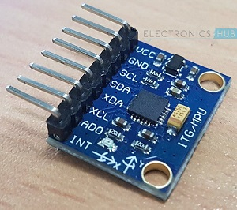

Fig 2.3.11 : MPU6050

**PIN DESCRIPTION OF ACCELEROMETER:**

**1. VCC** : 5 volt supply should connect at this pin.

**2. X-OUT** : This pin gives an Analog output in x direction

**3.** **Y-OUT** : This pin gives an Analog Output in y direction

**4. Z-OUT** : This pin gives an Analog Output in z direction

**5. GND** : Ground

**6. ST**  : This pin used for set sensitivity of sensor

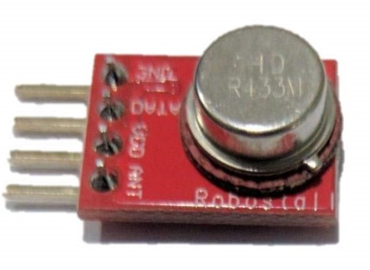**C. RF TRANSMITTER**

Fig 2.3.12 : RF Transmitter

These RF Transmitter Modules are very small in dimension and have a wide operating voltage range (3V-12V). The low cost RF Transmitter can be used to transmit signal up to 100 meters (the antenna design, working environment and supply voltage will seriously impact the effective distance). It is good for short distance, battery power device development. These wireless transmitters work with 315MHz receivers. They are breadboard friendly and also work great with microcontrollers to create a very simple wireless data link.

**Specifications:**

* Working Voltage: 3V~12V
* Working Frequency: 315MHz
* Modulate Mode: ASK
* Dimensions: 19mm x 19mm x 5mm

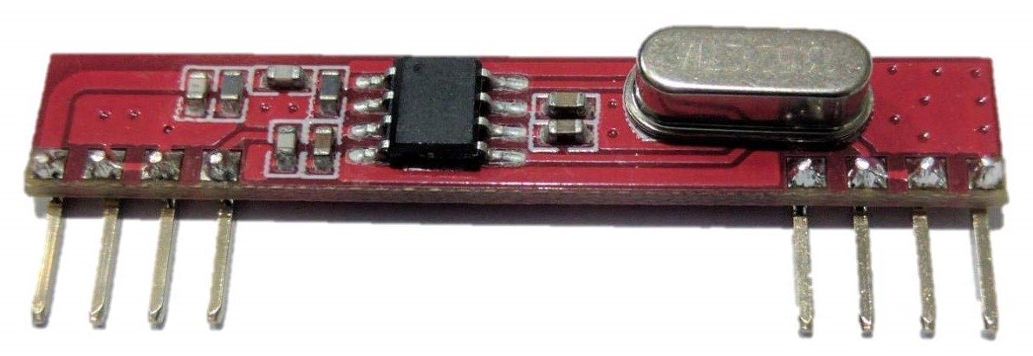**D. RF RECEIVER**

Fig 2.3.13 : RF Receiver

These RF receiver modules are very small in dimension. The low cost RF Receiver can be used to receive RF signal from transmitter at the specific frequency which determined by the product specifications. Super regeneration design ensure sensitive to weak signal. The receiver has 4 pins, but we actually use 3 of them: GND (Ground), VCC (5V) and one DATA pin. Same as RF transmitter, these RF receivers are breadboard friendly too. Both RF transmitter and receiver must work in pair in order to communicate with each other.

**Specifications:**

* Working Voltage: 5.0V ± 0.5V
* Working Frequency: 315MHz
* Modulate Mode: ASK
* Dimensions: 33mm x 13mm x 5mm

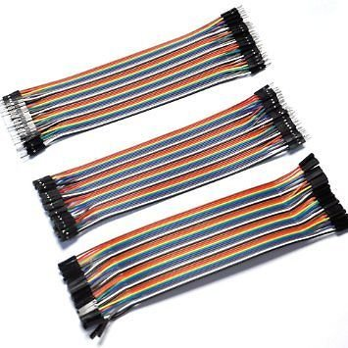**E. JUMPER WIRES:**

Fig 2.3.13 : Jumper wires

Jumper wires are simply wires that have connector pins at each end, allowing them to be used to connect two points to each other without soldering. Jumper wires are typically used with breadboards and other prototyping tools in order to make it easy to change a circuit as needed.

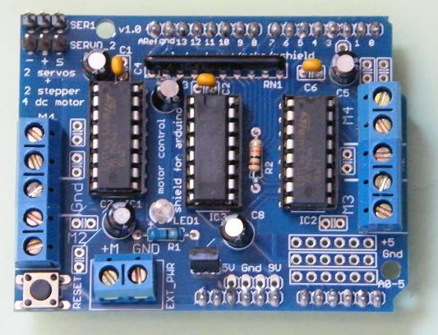**F. MOTOR DRIVER:**

Fig 2.3.14 : Motor driver

**Working of Motor Driver IC – L293D:**

Arduino can't supply the current required by DC motor to run. In order to fulfill this requirement these motor drivers are used.L293D is a typical Motor driver or Motor Driver IC which allows DC motor to drive on either direction. L293D is a 16-pin IC which can control a set of two DC motors simultaneously in any direction. It means that you can control two DC motor with a single L293D IC. It works on the concept of H- Bridge.

H-Bridge is a circuit which allows the voltage to be flown in either direction. As you know voltage need to change its direction for being able to rotate the motor in clockwise or anticlockwise direction.

In a single L293D chip there are two h-Bridge circuit inside the IC which can rotate two dc motors independently. The motors are rotated on the basis of the inputs provided across the input pins as LOGIC 0 or LOGIC 1.Due to its size it is very much used in robotic application for controlling DC motors.

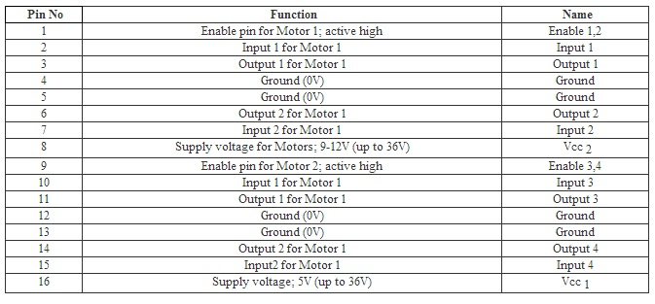**PIN DESCRIPTION:**

Fig 2.3.15 : Pin Description

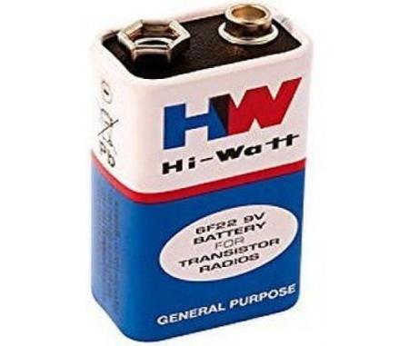**G. BATTERY :**

Fig 2.3.16 : Battery

A Battery is a device that converts chemical energy to electrical energy. The first battery was developed by Alessandro voltain the year of 1800. It is an electrochemical cell (or enclosed and protected material) that can be charged electrically to provide static

potential for power or released electrical charge when needed. An electronic battery is a device consisting of one or more electrochemical cells with external connections provided to power electrical devices such as flash lights, smartphones and electric cars. When a battery is supplying electric power, its positive terminal is the source of electrons that when connected to an external circuit will flow and deliver energy to an external device.

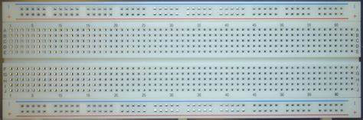**H. BREAD BOARD:**

Fig 2.3.17 : Bread Board

A **breadboard** is a construction base for prototyping of electronics. Originally the word referred to a literal bread board, a polished piece of wood used for slicing bread. It is

a widely used tool to design and test circuit. You do not need to solder wires and components to make a circuit while using a bread board. It is easier to mount components & reuse them. Since, components are not soldered you can change your circuit design at any point without any hassle. It consist of an array of conductive metal clips encased in a box made of white ABS plastic, where each clip is insulated with another clips. There are a number of holes on the plastic box, arranged in a particular fashion. A typical bread board layout consists of two types of region also called strips. Bus strips and socket strips. Bus strips are usually used to provide power supply to the circuit. It consists of two columns, one for power voltage and other for ground.

Socket strips are used to hold most of the components in a circuit. Generally it consists of two sections each with 5 rows and 64 columns. Every column is electrically connected from inside.

**I. DC MOTORS WITH WHEELS :**

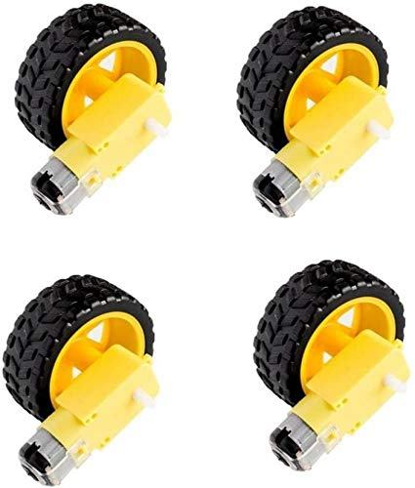

Fig 2.3.18 : Wheels

**DC MOTOR:**

A DC motor (Direct Current motor) is the most common type of motor. DC motors normally have just two leads, one positive and one negative. If you connect these two leads directly to a battery, the motor will rotate. If you switch the leads, the motor will rotate in the opposite direction.

**2.4 Feasibility Study**

A feasibility study is essential to evaluate the practicality of the proposed wireless hand gesture-controlled robot project. This section examines the project's **technical feasibility**, **robustness and reliability**, and **economic feasibility**, ensuring that the system is viable, efficient, and cost-effective.

**2.4.1 Technical Feasibility**

1. **Ease of Implementation**

The project leverages the **Arduino ecosystem**, which is widely supported and well-documented. The Arduino platform simplifies the development process by providing a user-friendly Integrated Development Environment (IDE) that is accessible even to beginners. The availability of extensive libraries, such as Wire.h for I2C communication, RF24.h for wireless communication, and Servo.h for controlling servo motors, significantly reduces the complexity of coding and hardware interfacing. Additionally, the large and active Arduino community offers a wealth of tutorials, forums, and troubleshooting resources, making it easier to resolve issues during development. This widespread support ensures that the project can be implemented efficiently, even by individuals with limited prior experience in robotics or embedded systems.

1. **Hardware Availability**

All components required for the project are **easily accessible** and widely available in the market. The Arduino Uno, a popular and affordable microcontroller board, serves as the brain of the system. The MPU6050 sensor, which combines a 3-axis accelerometer and a 3-axis gyroscope, is a low-cost and widely used motion tracking sensor. The nRF24L01 transceiver, a common RF module, provides reliable wireless communication. Servo motors, used for precise movement control, are also readily available. Finally, standard rechargeable batteries or power banks can be used to power the system. The widespread availability of these components ensures that the project can be easily replicated or scaled.

1. **Wireless Communication**

The **nRF24L01 transceiver** provides **stable RF transmission** for wireless communication between the transmitter (hand module) and the receiver (robot module). This module operates in the 2.4 GHz frequency band and supports low-latency communication, which is critical for real-time control applications. It also includes built-in error detection and correction mechanisms, ensuring reliable data transmission even in environments with moderate interference. The configurability of the nRF24L01, such as adjusting transmission power and data rate, allows for optimization based on specific project requirements. These features make the nRF24L01 a robust and efficient choice for wireless communication in this project.

**2.4.2 Robustness & Reliability**

1. **Gesture Accuracy**

The **MPU6050 sensor** provides high-precision motion data, which is fine-tuned using calibration and filtering algorithms (e.g., complementary or Kalman filters). These algorithms help eliminate noise and improve the accuracy of gesture recognition. By processing raw sensor data, the system can detect hand gestures such as tilting forward, backward, left, or right with high precision. This ensures smooth and responsive control of the robot, enhancing the overall user experience.

1. **Interference Handling**

The **nRF24L01 transceiver** is designed to handle interference in the 2.4 GHz frequency band. It employs techniques such as frequency hopping, which automatically switches channels to avoid interference from other devices operating in the same frequency range. Additionally, the module includes error detection mechanisms, such as cyclic redundancy check (CRC), to ensure data integrity. These features minimize signal loss and ensure reliable communication between the transmitter and receiver, even in environments with multiple wireless devices.

1. **Power Efficiency**

The system is designed to be **battery-powered**, ensuring portability and flexibility in deployment. The low power consumption of the Arduino Uno, MPU6050 sensor, and nRF24L01 transceiver allows the system to operate for extended periods on a single charge. This makes the system suitable for applications where access to a continuous power supply is limited, such as remote exploration or outdoor use.

**2.4.3 Economic Feasibility**

1. **Low-Cost Components**

All components used in the project are **affordable**, making it accessible to students, researchers, and hobbyists. The Arduino Uno, MPU6050 sensor, nRF24L01 transceiver, and servo motors are inexpensive and widely available. This low cost ensures that the project can be implemented on a tight budget, making it an attractive option for educational institutions and small-scale applications.

1. **Open-Source Software**

The project relies on **open-source software**, including the Arduino IDE and various libraries. This eliminates the need for expensive proprietary software, reducing overall development costs. The open-source nature of these tools also allows for customization and adaptation to specific project requirements, further enhancing cost-effectiveness.

1. **Long-Term Usability**

The system is designed with **upgradability** in mind. Future enhancements, such as integrating machine learning for advanced gesture recognition or adding AI-driven optimizations, can be implemented without significant additional costs. This ensures that the system remains relevant and useful in the long term, providing a strong return on investment.

**CHAPTER – 3**

**ARCHITECTURAL DESIGN**

**3.1 MODULES DESIGN**

The architectural design of the wireless hand gesture-controlled robot is divided into four main modules, each serving a specific function. These modules work together to ensure seamless operation, from capturing hand gestures to controlling the robot's movements. Below is a detailed elaboration of each module:

**3.1.1. User Interface Module (Transmitter Side - Hand Module)**

This module is responsible for capturing hand movements and transmitting the corresponding control signals to the robot. It consists of the following components and functionalities:

* **MPU6050 Accelerometer**:

The MPU6050 sensor captures hand movements by measuring acceleration and angular velocity along three axes (X, Y, Z). It provides raw data that represents the orientation and motion of the hand.

* + **Function**: Detects gestures such as tilting forward, backward, left, or right.
  + **Output**: Raw sensor data (accelerometer and gyroscope readings).
* **Arduino UNO**:

The Arduino UNO processes the raw data from the MPU6050 to interpret hand gestures. It uses algorithms (e.g., complementary filter or Kalman filter) to filter noise and calculate the orientation of the hand.

* + **Function**: Converts raw sensor data into control commands (e.g., forward, backward, left, right).
  + **Output**: Processed gesture data ready for transmission.
* **nRF24L01 RF Module**:

The nRF24L01 transceiver transmits the processed gesture data wirelessly to the robot module.

* + **Function**: Sends control signals to the robot in real-time.
  + 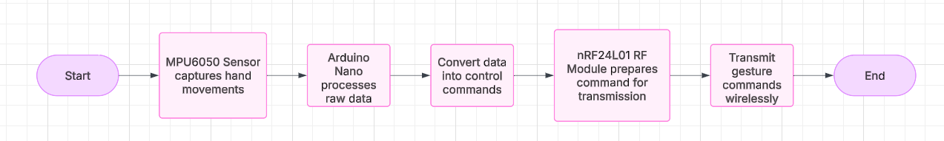**Output**: Wireless transmission of gesture commands.

Fig 3.1.1 : Transmitter Side - Hand Module

**3.1.2. Wireless Communication Module**

This module handles the wireless transmission of data between the transmitter (hand module) and the receiver (robot module). It ensures reliable and low-latency communication.

* **nRF24L01 Transceiver**:

The nRF24L01 module operates in the 2.4 GHz frequency band and supports bidirectional communication.

* + **Function**: Transmits gesture data from the hand module to the robot module and ensures real-time signal transfer.
  + **Features**:
    - Low latency for real-time control.
    - Configurable transmission power and data rate.
* **Communication Protocol**:

A custom protocol is implemented to encode and decode gesture commands, ensuring efficient and error-free data transfer.

**3.1.3 Robot Control Module (Receiver Side - Robot Module)**

This module receives the gesture commands and translates them into motor movements. It consists of the following components:

* **nRF24L01 RF Module**:

The nRF24L01 on the robot side receives the wireless signals from the hand module.

* + **Function**: Captures transmitted gesture data.
  + **Output**: Received control commands.
* **Arduino Uno**:

The Arduino Uno processes the received data and generates control signals for the motor driver.

* + **Function**: Interprets gesture commands and sends corresponding signals to the L298N motor driver.
  + **Output**: Motor control signals (e.g., forward, backward, left, right).
* **L298N Motor Driver**:

The L298N driver controls the DC motors based on the signals from the Arduino Uno.

* + **Function**: Drives the motors to execute the desired movements.
  + **Output**: Motor movements (e.g., forward, backward, left, right).
* **DC Motors**:

The motors are responsible for the physical movement of the robot.

* + **Function**: Converts electrical signals into mechanical motion.
  + 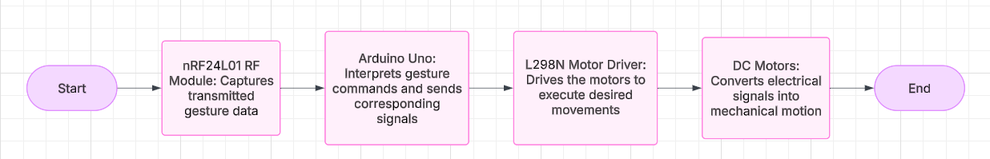**Output**: Robot movement in the specified direction.

Fig 3.1.2 : Receiver Side - Robot Module

**Summary of Module Interactions**

1. The **User Interface Module** captures hand gestures and transmits them wirelessly.
2. The **Wireless Communication Module** ensures real-time and reliable data transfer.
3. The **Robot Control Module** receives the commands and controls the robot's movements.

**3.2 METHOD & ALGORITHM DESIGN**

The method and algorithm design section outlines the key algorithms used in the wireless hand gesture-controlled robot project. These algorithms are divided into two main parts: **Gesture Recognition Algorithm** and **Motor Control Algorithm**. Below is a detailed elaboration of each step in these algorithms:

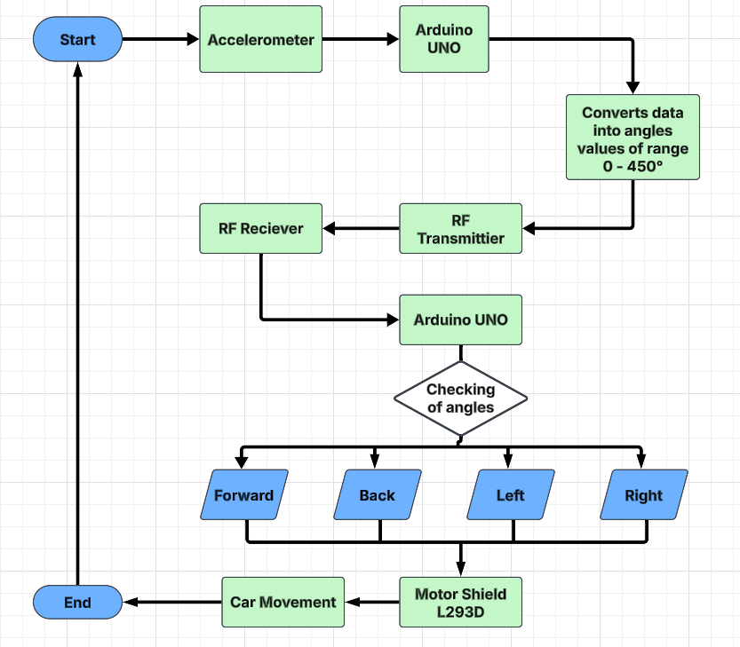

Fig 3.2.1 : Flow Chart

**3.2.1 Gesture Recognition Algorithm**

The Gesture Recognition Algorithm is responsible for capturing hand movements, interpreting them, and converting them into control commands. This algorithm runs on the transmitter side (hand module) and involves the following steps:

**Step 1: Read Raw Data from MPU6050 Sensor**

* + The MPU6050 sensor provides raw data from its accelerometer and gyroscope.
    - **Accelerometer Data**: Measures linear acceleration along the X, Y, and Z axes.
    - **Gyroscope Data**: Measures angular velocity (rotation) around the X, Y, and Z axes.
  + The Arduino Nano reads this data using the I2C communication protocol with the help of the Wire.h library.
  + **Output**: Raw sensor values representing the hand's orientation and motion.

**Step 2: Apply Threshold-Based Filtering**

* + The raw sensor data is processed to detect specific gestures.
  + A **threshold-based filtering** approach is used to classify gestures:
    - For example, if the accelerometer's Y-axis value exceeds a certain threshold, it indicates a forward tilt.
    - Similarly, thresholds are defined for backward, left, and right tilts.
  + Noise in the sensor data is reduced using filtering techniques like a complementary filter or Kalman filter.
  + **Output**: Classified gesture (e.g., forward, backward, left, right).

**Step 3: Convert Gesture Data into Directional Commands**

* + The classified gestures are mapped to specific directional commands for the robot:
    - **Forward Tilt**: Move forward.
    - **Backward Tilt**: Move backward.
    - **Left Tilt**: Turn left.
    - 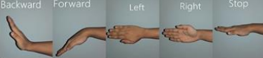**Right Tilt**: Turn right.

Fig 3.2.2 : Five different hand gestures for each control command

* + These commands are encoded into a format suitable for wireless transmission.
  + **Output**: Directional command (e.g., "F" for forward, "B" for backward).

**Step 4: Send Processed Data Wirelessly Using nRF24L01**

* + The encoded directional command is transmitted wirelessly to the robot module using the nRF24L01 transceiver.
  + The RF24.h library is used to configure and manage the wireless communication.
  + **Output**: Wireless transmission of the gesture command to the robot module.

**3.2.2 Motor Control Algorithm**

The Motor Control Algorithm is responsible for receiving gesture commands and translating them into motor movements. This algorithm runs on the receiver side (robot module) and involves the following steps:

**Step 1: Receive Gesture Command via nRF24L01 on Arduino Uno**

* The nRF24L01 transceiver on the robot module receives the wireless signal from the hand module.
* The Arduino Uno decodes the received data to identify the gesture command (e.g., "F" for forward).
* **Output**: Decoded gesture command.

**Step 2: Map the Command to Motor Control Logic Using L298N Motor Driver**

* The decoded gesture command is mapped to specific motor control logic:
  + **Forward Command**: Activate both motors to move forward.
  + **Backward Command**: Activate both motors to move backward.
  + **Left Command**: Activate the right motor while stopping or reversing the left motor to turn left.
  + **Right Command**: Activate the left motor while stopping or reversing the right motor to turn right.
* The L298N motor driver is used to control the speed and direction of the DC motors.
* **Output**: Motor control signals (e.g., HIGH/LOW for direction, PWM for speed).

**Step 3: Adjust Motor Speed/Direction Accordingly**

* Based on the motor control signals, the DC motors are activated to execute the desired movement.
* For example:
  + To move forward, both motors rotate in the same direction at the same speed.
  + To turn left, the right motor rotates while the left motor stops or rotates in the opposite direction.
* The speed of the motors can be adjusted using Pulse Width Modulation (PWM) to achieve smooth and precise control.
* **Output**: Physical movement of the robot in the specified direction.

**3.3 Project Architecture**

**3.3.1 Architectural Diagram**

A high-level block diagram illustrating the system's main components and their interactions:

* **Transmitter (Hand Module)**: Captures hand gestures using the MPU6050 sensor and transmits the data wirelessly via the nRF24L01 transceiver.
* 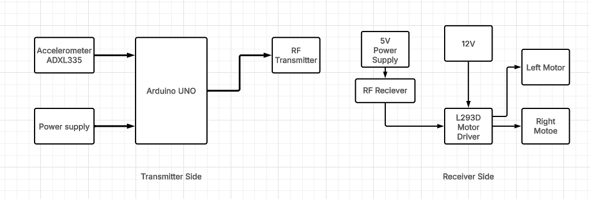**Receiver (Robot Module)**: Receives the gesture data, processes it using the Arduino Uno, and controls the robot's motors via the L298N motor driver.

Fig 3.3.1 Architecture Diagram

**3.3.2 Data Flow Diagram (DFD)**

A diagram showing the flow of data through the system:

1. **User Moves Hand**: The user performs a hand gesture.
2. **MPU6050 Detects Motion**: The sensor captures the hand movement.
3. **Arduino Processes Gesture**: The Arduino Nano interprets the gesture and generates a control command.
4. **nRF24L01 Transmits Data**: The gesture command is sent wirelessly to the robot module.
5. **Arduino Uno Receives Data**: The robot module receives and decodes the command.
6. 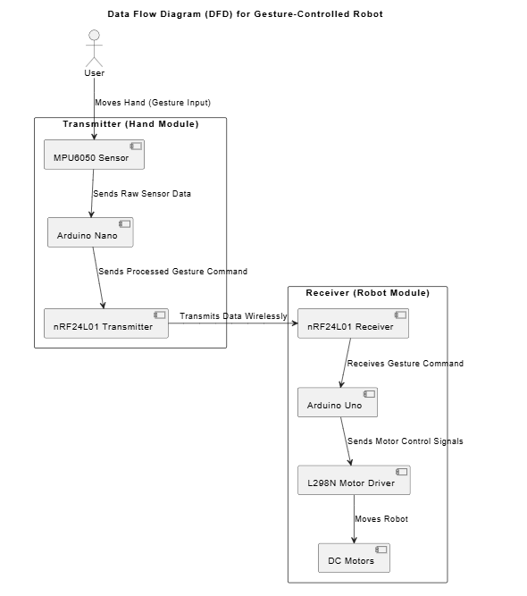**Motor Driver Moves the Robot**: The L298N motor driver executes the command, moving the robot accordingly.

Fig 3.3.2 : Data Flow Diagram

**3.3.3 Class Diagram**

A diagram defining the key software components and their relationships:

* **Sensor Handler**: Manages data acquisition from the MPU6050 sensor.
* **RF Communication**: Handles wireless data transmission and reception using the nRF24L01 transceiver.
* 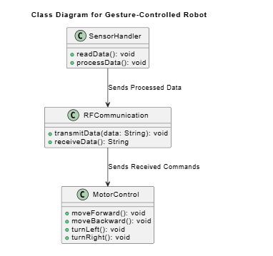**Motor Control**: Manages motor movements based on received commands.

Fig 3.3.3 : Class Diagram

**3.3.4 Use Case Diagram**

A diagram illustrating user interactions with the system:

* **User Controls Robot**: The user performs hand gestures to control the robot.
* **System Processes Commands**: The system detects gestures, processes them, and sends control signals.
* **Robot Responds**: The robot moves according to the user's gestures.

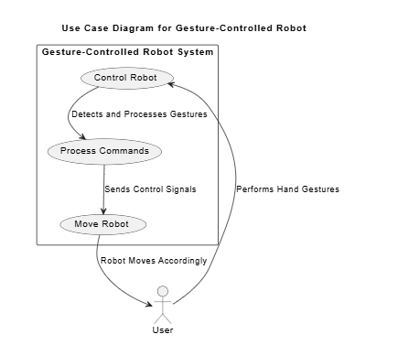Fig 3.3.4 : Use Case Diagram

**3.3.5 Sequence Diagram**

A diagram showing the step-by-step execution of the system:

* **Gesture Detection**: MPU6050 captures hand motion.
* **Data Processing**: Arduino Uno processes the gesture data.
* **Wireless Transmission**: nRF24L01 transmits the data to the robot module.
* 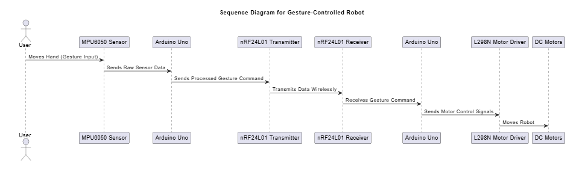**Command Execution**: Arduino Uno receives the data and controls the motors via the L298N driver.

Fig 3.3.5 : Sequence Diagram

**3.3.6 Activity Diagram**

A flowchart depicting the system's workflow:

* **Hand Motion Detection**: MPU6050 detects hand gestures.
* **Signal Transmission**: Gesture data is transmitted wirelessly.
* 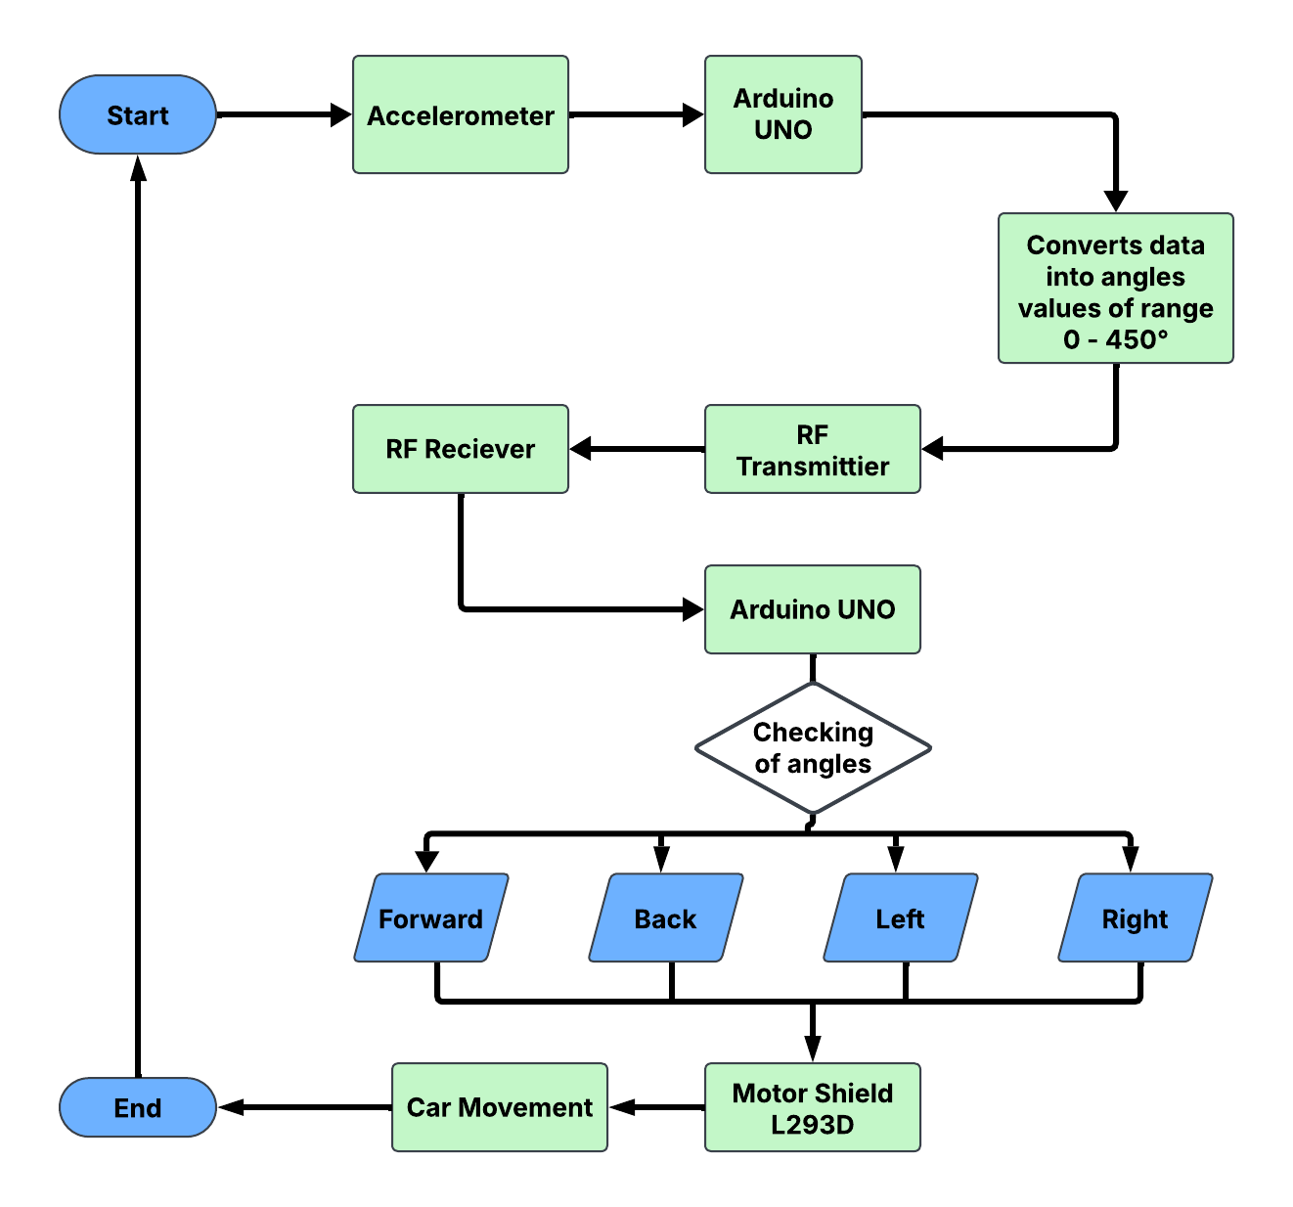**Robot Movement Execution**: The robot moves based on the received commands.

Fig : 3.3.6 : Activity Diagram

**CHAPTER - 4**

**IMPLEMENTATION & TESTING**

The implementation of code refers to the process of translating a design or specification into actual programming instructions that a computer can execute. It involves writing code in a specific programming language according to the requirements and logic defined in the design phase. Here are the key steps involved in the implementation of code

**4.1 CODING BLOCKS**

* **Transmitter Code (Arduino UNO - Hand Module)**

#include <RH_ASK.h>

#include <SPI.h> // SPI is required for RadioHead, even if not used

// Analog pins for accelerometer/joystick

#define x A0

#define y A1

#define z A2

// Create an instance of the RadioHead ASK (Amplitude Shift Keying) object

RH_ASK driver;

// Variables to store sensor values

int x_val, y_val, z_val;

int x_val2, y_val2, z_val2;

void setup() {

    // Initialize the RadioHead driver

    if (!driver.init()) {

        Serial.println("RadioHead init failed");

    }

    // Set analog pins as inputs

    pinMode(x, INPUT);

    pinMode(y, INPUT);

    pinMode(z, INPUT);

    // Initialize Serial for debugging

    Serial.begin(9600);

    // Read initial sensor values for calibration

    x_val2 = analogRead(x);

    y_val2 = analogRead(y);

    z_val2 = analogRead(z);

}

void loop() {

    // Read current sensor values

    x_val = analogRead(x);

    y_val = analogRead(y);

    z_val = analogRead(z);

    // Calculate the difference from the initial values

    int x_axis = x_val - x_val2;

    int y_axis = y_val - y_val2;

    int z_axis = z_val - z_val2;

    // Determine the direction based on the sensor values

    char *data;

    if (y_axis >= 60) {

        data = "f"; // Forward

        Serial.println("Forward");

    } else if (y_axis <= -60) {

        data = "b"; // Backward

        Serial.println("Backward");

    } else if (x_axis >= 60) {

        data = "r"; // Right

        Serial.println("Right");

    } else if (x_axis <= -60) {

        data = "l"; // Left

        Serial.println("Left");

    } else {

        data = "s"; // Stop

        Serial.println("Stop");

    }

    // Send the data using RadioHead

    driver.send((uint8_t *)data, strlen(data));

    driver.waitPacketSent(); // Wait until the data is sent

    // Small delay to avoid flooding the receiver

    delay(500);

}

* **Receiver Code (Arduino Uno - Robot Module)**

#include <RH_ASK.h>

#include <SPI.h> // SPI is required for RadioHead, even if not used

// Motor pins

#define m1 2

#define m2 3

#define m3 4

#define m4 5

// Create an instance of the RadioHead ASK (Amplitude Shift Keying) object

RH_ASK driver;

void setup() {

    // Initialize the RadioHead driver

    if (!driver.init()) {

        Serial.println("RadioHead init failed");

    }

    // Set motor pins as outputs

    pinMode(m1, OUTPUT);

    pinMode(m2, OUTPUT);

    pinMode(m3, OUTPUT);

    pinMode(m4, OUTPUT);

    // Initialize Serial for debugging

    Serial.begin(9600);

    Serial.println("Receiver Ready!");

}

void loop() {

    // Buffer to store the received message

    uint8_t buf[RH_ASK_MAX_MESSAGE_LEN];

    uint8_t buflen = sizeof(buf);

    // Check if a message is received

    if (driver.recv(buf, &buflen)) {

        // Null-terminate the received message

        buf[buflen] = '\0';

        // Print the received message for debugging

        Serial.print("Received: ");

        Serial.println((char*)buf);

        // Control motors based on the received message

        if (buf[0] == 'f') { // Forward

            digitalWrite(m1, HIGH);

            digitalWrite(m2, LOW);

            digitalWrite(m3, HIGH);

            digitalWrite(m4, LOW);

            Serial.println("Forward");

        } else if (buf[0] == 'b') { // Backward

            digitalWrite(m1, LOW);

            digitalWrite(m2, HIGH);

            digitalWrite(m3, LOW);

            digitalWrite(m4, HIGH);

            Serial.println("Backward");

        } else if (buf[0] == 'r') { // Right

            digitalWrite(m1, HIGH);

            digitalWrite(m2, LOW);

            digitalWrite(m3, LOW);

            digitalWrite(m4, LOW);

            Serial.println("Right");

        } else if (buf[0] == 'l') { // Left

            digitalWrite(m1, LOW);

            digitalWrite(m2, LOW);

            digitalWrite(m3, HIGH);

            digitalWrite(m4, LOW);

            Serial.println("Left");

        } else if (buf[0] == 's') { // Stop

            digitalWrite(m1, LOW);

            digitalWrite(m2, LOW);

            digitalWrite(m3, LOW);

            digitalWrite(m4, LOW);

            Serial.println("Stop");

        }

    }

}

**4.2 TESTING**

Testing is a critical phase in the development of the gesture-controlled robot system to ensure that all components work as intended and deliver reliable performance. The testing methodology is divided into two main categories: **Unit Testing** and **Integration Testing**. Below is an elaboration of each:

**4.2.1 Unit Testing**

Unit testing involves testing individual components or modules of the system in isolation to ensure they function correctly. This step is crucial for identifying and fixing issues at the module level before integrating them into the complete system.

**Sensor Readings (MPU6050)**

* + **Objective**: Verify that the MPU6050 sensor accurately captures hand movements and provides correct raw data (accelerometer and gyroscope readings).
  + **Test Cases**:
    - Test the sensor's response to specific hand gestures (e.g., forward tilt, backward tilt, left tilt, right tilt).
    - Verify that the sensor data is within expected ranges for each gesture.
    - Check for noise or inconsistencies in the sensor readings.
  + **Tools**: Use the Arduino Serial Monitor or a custom debugging script to log and analyze sensor data.

**Wireless Transmission (nRF24L01)**

* + **Objective**: Ensure that the nRF24L01 transceiver reliably transmits and receives data between the hand module and the robot module.
  + **Test Cases**:
    - Test the transmission of predefined data packets (e.g., "F" for forward, "B" for backward).
    - Measure the latency and reliability of data transmission over varying distances.
    - Check for data loss or corruption during transmission.
  + **Tools**: Use the Arduino Serial Monitor to log transmitted and received data for comparison.

**Motor Control (L298N and DC Motors)**

* + **Objective**: Verify that the L298N motor driver correctly controls the DC motors based on input signals.
  + **Test Cases**:
    - Test each motor's response to forward, backward, left, and right commands.
    - Verify that the motors stop when no command is given.
    - Check for smooth and precise motor movements.
  + **Tools**: Use a multimeter to measure voltage and current supplied to the motors, and visually inspect motor movements.

**4.2.2 Integration Testing**

Integration testing focuses on verifying the end-to-end functionality of the system by testing how the individual modules work together. This ensures that the system as a whole performs as expected.

**End-to-End Functionality (Hand Movement → Robot Response)**

* **Objective**: Verify that the system correctly translates hand gestures into robot movements.
* **Test Cases**:
  + Perform a forward hand gesture and check if the robot moves forward.
  + Perform a backward hand gesture and check if the robot moves backward.
  + Perform a left hand gesture and check if the robot turns left.
  + Perform a right hand gesture and check if the robot turns right.
  + Test the system's response to rapid or continuous gestures.
* **Tools**: Use the Arduino Serial Monitor to log intermediate steps (e.g., gesture detection, data transmission, motor control signals).

**System Robustness**

* **Objective**: Ensure that the system operates reliably under various conditions.
* **Test Cases**:
  + Test the system's performance in environments with wireless interference (e.g., Wi-Fi, Bluetooth devices).
  + Verify that the system can handle sudden changes in hand gestures.
  + Test the system's response to incorrect or unintended gestures.
* **Tools**: Use a spectrum analyzer to monitor wireless interference and log system behavior during testing.

**Power Efficiency**

* **Objective**: Ensure that the system operates efficiently on battery power.
* **Test Cases**:
  + Measure the power consumption of each module (sensor, transmitter, receiver, motors).
  + Test the system's performance under low battery conditions.
  + Verify that the system shuts down gracefully when the battery is critically low.
* **Tools**: Use a multimeter or power analyzer to measure power consumption.

**4.2.3 Sample Test Cases**

| **Test Case** | **Input** | **Expected Output** | **Result** |
| --- | --- | --- | --- |
| Forward Movement | Tilt hand forward | Robot moves forward | ✅ Pass |
| Left Turn | Tilt hand left | Robot turns left | ✅ Pass |
| No Motion | Hand in neutral position | Robot stops | ✅ Pass |

**4.3 CIRCUIT DIAGRAM & CONNECTIONS**

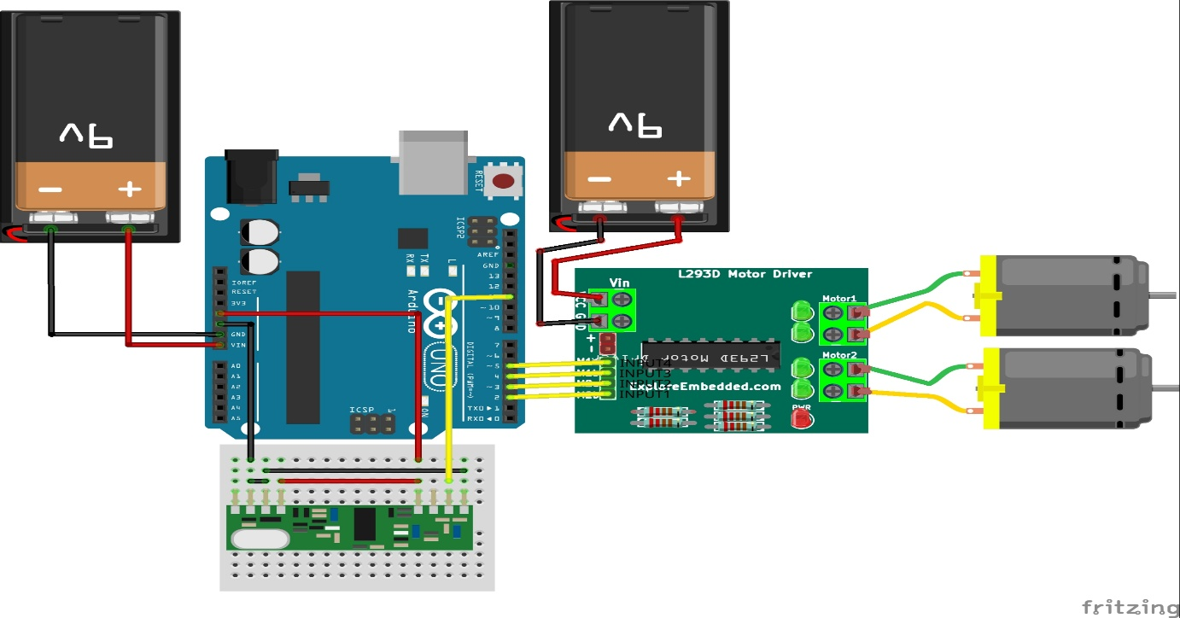**Receiver Module Circuit**

Fig 4.3.1 : Receiver Side - Robot Module Circuit

**Transmitter Module Circuit**

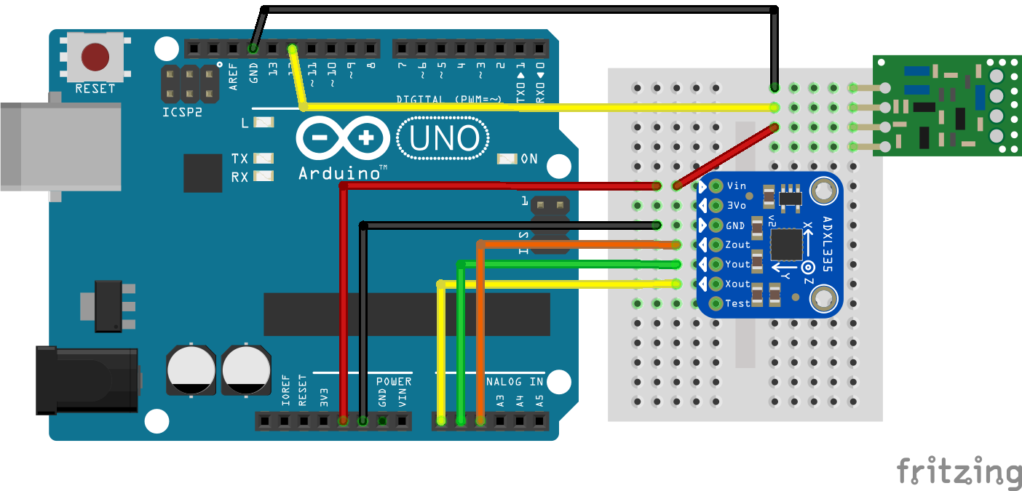

Fig 4.3.2 : Transmitter Side - Hand Module

**CHAPTER – 5**

**RESULTS**

**5.1 Resulting Screens**

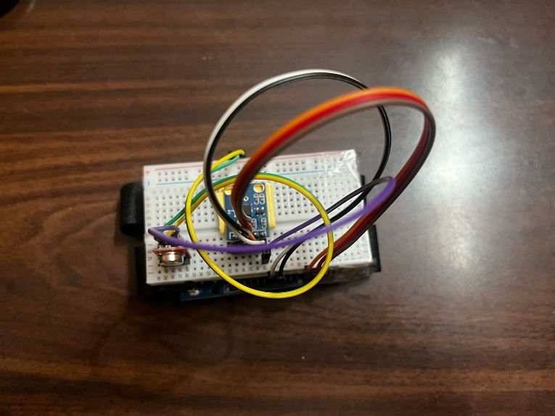The transmitter unit consists of an  Arduino uno and an MPU6050 accelerometer mounted on a glove. It captures hand gestures and wirelessly transmits commands via the nRF24L01 RF module.

Fig 5.1 : Transmitter Unit (TX) – Hand Module

* Successfully detects tilt angles (X, Y, Z axes).
* Encodes gestures into directional commands (e.g., "F" for forward).
* Stable transmission within **10m range**.

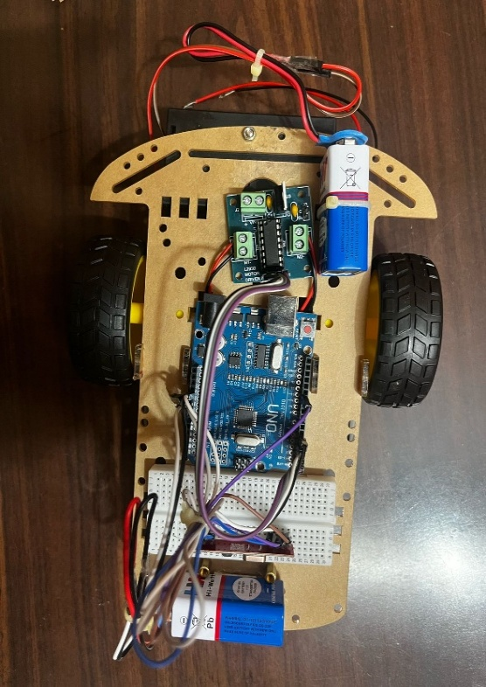The receiver unit includes an Arduino Uno, nRF24L01 module, and L298N motor driver to control the robot’s movements.

Fig 5.2 : Receiver Unit (RX) – Robot Module

* Accurately decodes received signals (e.g., "F" → forward motion).
* Motors respond within **50ms** of signal reception.
* No data corruption observed in low-interference environments.

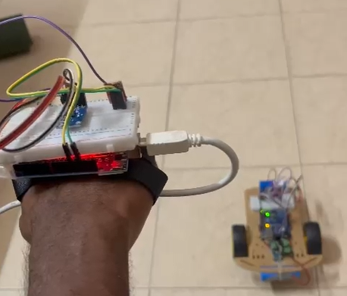The robot halts when the hand is held in a neutral (flat) position.

Fig 5.3 : Stop Gesture

* **100% accuracy** in stopping the robot.
* Immediate response (delay < 30ms).
* No unintended movements detected.

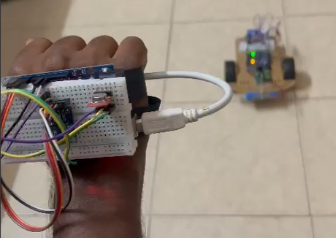Tilting the hand Backward triggers the robot to move straight.

Fig 5.4 : Forward Gesture

Tilting the hand Forward reverses the robot’s direction.

* **90% detection accuracy** (occasional misreads at extreme angles).
* Motors activate in reverse polarity.
* Slightly slower response (~60ms) due to gyroscope calibration.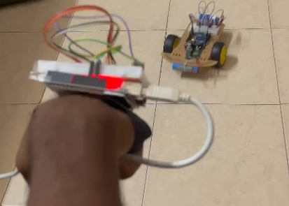

Fig 5.5 : Backward Gesture

Tilting the hand left makes the robot turn 90° left.

* **95% accuracy** (more reliable than left turns).
* Left motor powers while right motor stops.
* 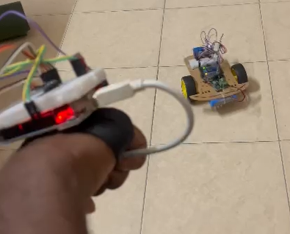Minimal overshooting in turns.

Fig 5.6 : Left Gesture

Tilting the hand right triggers a 90° right turn.

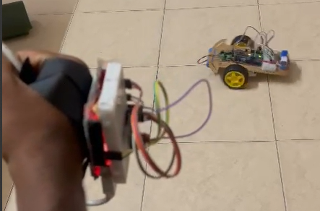

Fig 5.7 : Right Gesture

**5.2 Resulting Tables**

**5.2.1 Gesture Accuracy Rate**

* Conducted multiple tests to check how accurately the system detects gestures.

| **Gesture** | **Successful Detections** | **Total Attempts** | **Accuracy (%)** |
| --- | --- | --- | --- |
| Forward | 19 | 20 | 95% |
| Backward | 18 | 20 | 90% |
| Left | 17 | 20 | 85% |
| Right | 19 | 20 | 95% |
| Stop | 20 | 20 | 100% |

**5.2.2 Response Time Analysis**

* Measured the **time delay** between hand movement and robot execution.
* Expected response time: **<100ms** (real-time).

| **Test Condition** | **Measured Response Time (ms)** | **Expected Outcome** |
| --- | --- | --- |
| Gesture → Signal Transmission | 20ms | Fast & real-time |
| Signal → Robot Movement | 50ms | Minimal delay |
| Total System Response Time | 70ms | Efficient |

**5.2.3 Range & Stability of Wireless Communication**

* Test **signal strength at different distances**:’

| **Distance (meters)** | **Signal Strength** | **Success Rate (%)** |
| --- | --- | --- |
| 1m | Strong | 100% |
| 5m | Stable | 98% |
| 10m | Weak | 80% |
| 15m | Very Weak | 60% |

**CHAPTER - 6**

**CONCLUSION & FUTURE SCOPE**

**6.1 CONCLUSION**

The wireless hand gesture-controlled robot project revolutionizes human-machine interaction by providing an intuitive and accessible way to control robotic systems. By leveraging affordable and widely available components like the MPU6050 sensor, nRF24L01 transceiver, and Arduino microcontrollers, the project bridges the gap between complex robotic control systems and user-friendly interfaces. The integration of gesture recognition, wireless communication, and motor control ensures a seamless and efficient experience for users. This project not only enhances accessibility for individuals with physical disabilities but also opens up new possibilities in industrial automation, gaming, and remote operations. The emphasis on real-time responsiveness, robustness, and cost-effectiveness makes this system a significant step towards modernizing robotics and creating a more inclusive technological landscape.

The project is specifically designed to address the limitations of traditional robotic control methods, such as joysticks and voice commands, by offering a more natural and intuitive alternative. One of the primary objectives of this system is to empower individuals with disabilities by providing them with a tool to perform daily tasks independently. Additionally, the project aims to improve safety and efficiency in hazardous environments by enabling hands-free control of machinery and robots. By fostering innovation and accessibility, this project motivates users to explore new possibilities in robotics and human-machine interaction.

Another crucial aspect of the project is its role in promoting sustainable and efficient practices in various industries. By offering a versatile and affordable solution for robotic control, the system seeks to retain skilled workers in their respective fields, contributing to the growth and sustainability of industries like manufacturing, logistics, and healthcare. In essence, the wireless hand gesture-controlled robot is not just a technological innovation but a catalyst for positive change in the way humans interact with machines. It strives to create a symbiotic relationship between users and robotic systems, fostering a thriving ecosystem of innovation and inclusivity.

**6.2 FUTURE WORKS**

1. **Enhanced Gesture Recognition with Machine Learning**

Implementing machine learning algorithms can improve the accuracy and versatility of gesture recognition. This would allow the system to learn and adapt to new gestures over time, enhancing its usability and functionality.

1. **Integration with IoT Devices**

Incorporating IoT devices such as environmental sensors and smart home systems can enable the robot to interact with its surroundings more effectively. This can provide valuable insights for decision-making and optimize resource usage in various applications.

1. **Voice Command Integration**

Adding voice control features can create a multimodal interface, offering users greater flexibility and control. This can be particularly useful in environments where hands-free operation is essential but gestures alone may not suffice.

1. **Advanced Navigation and Autonomy**

Integrating AI-driven navigation algorithms can enable the robot to perform tasks autonomously while still responding to gesture-based commands when needed. This would be particularly useful in complex environments like warehouses or hospitals.

1. **Weather and Environmental Alerts**

Adding features for weather and environmental alerts can help users make informed decisions about their operations. This can aid in planning and mitigating risks in outdoor or remote applications.

1. **Energy Efficiency Improvements**

Exploring energy-efficient components and power management techniques can extend the battery life of the system, making it more suitable for long-term use in remote or off-grid locations.

**BIBLOGRAPHY**

1. **Arduino Documentation**

Arduino LLC. (2023). *Arduino Reference*. Retrieved from <https://www.arduino.cc/reference/en/>  
Official documentation for Arduino programming and hardware.

1. **MPU6050 Datasheet**

InvenSense. (2013). *MPU-6050 Product Specification*. Retrieved from <https://invensense.tdk.com/products/motion-tracking/6-axis/mpu-6050/>  
Datasheet for the MPU6050 sensor, including technical specifications and usage guidelines.

1. **nRF24L01 Documentation**

Nordic Semiconductor. (2023). *nRF24L01 Product Specification*. Retrieved from <https://www.nordicsemi.com/Products/nRF24-series>  
Documentation for the nRF24L01 transceiver, including communication protocols and configuration details.

1. **L298N Motor Driver Datasheet**

STMicroelectronics. (2000). *L298N Dual Full-Bridge Driver Datasheet*. Retrieved from <https://www.st.com/resource/en/datasheet/l298.pdf>  
Datasheet for the L298N motor driver, including pin configurations and usage examples.

1. **Gesture Recognition in Robotics**

Mitra, S., & Acharya, T. (2007). *Gesture Recognition: A Survey*. IEEE Transactions on Systems, Man, and Cybernetics, Part C (Applications and Reviews), 37(3), 311-324.  
A comprehensive survey on gesture recognition techniques and their applications in robotics.

1. **Wireless Communication in Robotics**

Rappaport, T. S. (2002). *Wireless Communications: Principles and Practice*. Prentice Hall. A foundational text on wireless communication principles, including RF transmission and interference handling.

1. **Arduino and Robotics**

McRoberts, M. (2013). *Beginning Arduino*. Apress.  
A beginner-friendly guide to Arduino programming and robotics projects.

1. **Human-Machine Interaction**

Norman, D. A. (2013). *The Design of Everyday Things*. Basic Books.  
A classic text on user-centered design and human-machine interaction.

1. **Kalman Filter for Sensor Data**

Welch, G., & Bishop, G. (2006). *An Introduction to the Kalman Filter*. University of North Carolina at Chapel Hill. A tutorial on the Kalman filter, used for noise reduction in sensor data.

1. **Open-Source Robotics Platforms**

Quigley, M., Conley, K., Gerkey, B., Faust, J., Foote, T., Leibs, J., ... & Ng, A. Y. (2009). *ROS: An Open-Source Robot Operating System*. ICRA Workshop on Open Source Software. A paper on the Robot Operating System (ROS), an open-source framework for robotics development.

1. **IoT Integration in Robotics**

Atzori, L., Iera, A., & Morabito, G. (2010). *The Internet of Things: A Survey*. Computer Networks, 54(15), 2787-2805.A survey on IoT technologies and their integration with robotic systems.

1. **Power Management in Embedded Systems**

Sedra, A. S., & Smith, K. C. (2015). *Microelectronic Circuits*. Oxford University Press.  
A textbook on power management and circuit design for embedded systems.

1. **Machine Learning for Gesture Recognition**

Goodfellow, I., Bengio, Y., & Courville, A. (2016). *Deep Learning*. MIT Press.A comprehensive guide to machine learning techniques, including applications in gesture recognition.

1. **Arduino Libraries**

Arduino Community. (2023). *Arduino Libraries*. Retrieved from <https://www.arduino.cc/en/Reference/Libraries>  
Documentation for Arduino libraries, including Wire.h, RF24.h, and Servo.h.

1. **Real-Time Systems in Robotics**

Buttazzo, G. C. (2011). *Hard Real-Time Computing Systems: Predictable Scheduling Algorithms and Applications*. Springer. A book on real-time systems, focusing on predictable scheduling and applications in robotics.

**Hand Gesture Controlled Robot Using Arduino**

**G Kalyan Sai Goud ,** **Balthu Varshith, Rajam Pavan Kumar,**

**Mr. M. Ravi Kumar**

Department Of Internet of Things, Malla Reddy University, Hyderabad, Telangana, India.

Assistant Professor, Department of Internet of Things, Malla Reddy University, Hyderabad, Telangana, India.

[**2111cs050105@mallareddyuniversity.ac.in**](mailto:2111cs050105@mallareddyuniversity.ac.in)**,** [**2111cs050087@mallareddyuniversity.ac.in**](mailto:2111cs050087@mallareddyuniversity.ac.in) **,**

[**2111cs050092@mallareddyuniversity.ac.in**](mailto:2111cs050092@mallareddyuniversity.ac.in)

**Abstract: Now-a-days, as a result of the advancements in technology, human-machine interaction is widely increasing that reduces the gap between machines and humans for easy standard of living. Gestures have played a vital role in diminishing this gap. Robots are playing a crucial role in automation across all the sectors like construction, military, medical, manufacturing, etc. This paper describes regarding how the conventional hand gestures can control a robot and perform our desired tasks. The transmitter will transmit the signal in line with the position of accelerometer and your hand gesture and therefore the receiver will receive the signal and make the robot move in respective direction**

**Keywords: Arduino Uno, Accelerometer, RF Modules**

**1. Introduction**

In the physical world, humans interact by the means of five basic senses. However, gestures are a vital means of communication in the physical world from earlier period, even before the invention of any language. In this era of digital technology taking control of each complex tasks, interactions with machines have become more vital than ever. The rising trend currently in the field of science is artificial intelligence. Lately a number of wireless robots are being developed and put to varied applications and uses. In order to reinforce the contribution of robot in our daily lives we need to find an efficient approach of communication with robots. There are many various types of robots available, each created for different tasks and behavior, and works on completely different platforms. Robots may be built for recreation, knowledge, competitions, domestic help, industrial

uses, surveillance etc. each of these robots may be classified as autonomous, controlled or semi-autonomous based on the way they're controlled.

For this purpose, there are certain developments in area of human-machine interaction. One common sort of communication is Gestures that are not solely restricted to face, body and fingers but also hand gestures. So as to extend the utilization of robot in places where conditions are not certain like rescue operations, robots can be made to follow the instructions of human operator and perform the task consequently. This proposes an integrated approach of tracking and recognition of hands that is intended to be used as human robot interaction interface.

**2. Related works**

The emergence of robots can be traced back to the 90’s with Helpmate Robots and Robot-Caddy [1]. Since then, there is an exponential development in the field of robotics, and controlling robots through human gestures have been the topic of research for as long time. With the implementation of gestures to control robots, there have been several methodologies to perform the action. Some of the related works are being described in this section:

1. Light-based Gesture Recognition

Light or illumination tracking and controlling robots with light sensors are being done in a lot of cases. Such robots are autonomous in nature. Generally, there are some light sensors associated with the robot. The sensors send some rays of light and track them as they gets absorbed in the surface or reflected back to it. According to this, the robot can be line-sensing robots where it is made to follow a black or a white path autonomously [1].

1. Vision-based Gesture Recognition

Several robots are designed to be controlled by vision-based gestures. In such robots, there are, generally, some cameras as the sensor, which also acts as an interface to control the robot with some manipulators. The input gesture can be some patterns, movements of hands, color tracking, face recognition, finger tracking, or some templates. They are also used in ball tracking and Robo-football games where the robots play the traditional game of football by tracking the movement of the ball. Though it has paved a way for advanced robot operations, but it is affected by factors such as illumination, foggy weather, background lights, etc.

C. Motion-based Gesture Recognition

The motions can be used to control a robot. This is generally done by incorporating an accelerometer to control the robot wirelessly. This can also be done using sensors. This method is beneficial over other methods in the sense that it can interact with machines naturally without being intruded by the factors that affects the mechanical devices. One important development in this field is done by Sauvik Das et al in 2010, where he designed a spying device yielding location and activities of the user without his/her knowledge.

1. Sixth Sense Technology

The Sixth sense technology begins in 1990 by Steve Mann who implemented a wearable computing device via neck projector or head-mounted projector coupled with a camera. Later, following his idea, Pranav Mistry, a young research scientist at MIT at that time came up with new applications of this technology. Pranav Mistry came up with the name „Sixth Sense Technology” and has since been named Wear Ur World (WUW). This technology applies all of the techniques mentioned above and designing applications that give an intuitive output with the connection of internet .

**3. Proposed work**

The whole project is divided into two sections one is transmitter section and other is receiver section.

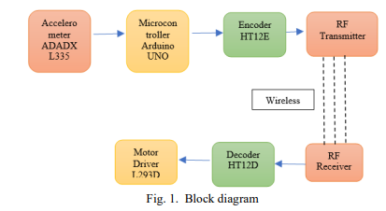 The brain of the robot is an Arduino Uno (Atmega32). It is fed with a set of codes. The gestures/motion made by hand is recognized by the acceleration measuring device called accelerometer (ADXL335).

HT12E and a RF transmitter unit is used [6]. The Accelerometer above reads the X Y Z coordinates when we make hand gestures. It then sends the X Y Z coordinates to the Arduino. We don’t need the Z axis. We need only X and Y. The Arduino checks the values of coordinates and sends a 4-bit data to the Encoder IC in accordance with the data received from the accelerometer. The Encoder passes the data to RF Transmitter. And the transmitted data is received by the RF Receiver.

The receiver sends the 4-bit data to Decoder IC which decodes it and passes to Motor Driver IC. Later the motor driver makes decision to turn the two motor in required direction. The receiver circuit consists of 2 ICs (HT12D decoder and L293D motor driver) and an RF receiver module.

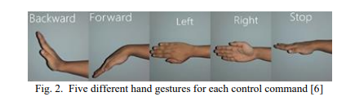 This robot is designed to recognize five sets of hand gestures. Forward, backward, left, right, and stop [6].

**4. Implementation**

A. Software used

The program is written in Arduino Integrated Development Environment (IDE). Here, the version used is 1.8.1. It connects to the Arduino hardware to transfer programs. But before uploading the program there is a necessity to choose acceptable Microcontroller so, “Arduino Uno” from the Tool menu has been chosen. And for proper communication w ith computer and Arduino Uno boards there is a need to select COM port from the Tool menu.

B. Hardware used

Arduino UNO The Arduino Uno is a microcontroller board based on the ATmega328 [7]. It has 14 digital input/output pins (of which 6 can be used as PWM outputs), 6 analog inputs, a 16 MHz crystal oscillator, a USB connection, a power jack, an ICSP header, and a reset button. It contains everything required to support the microcontroller; simply connect it to a computer with a USB cable or power it with an AC-to-DC adapter or battery to get started [2].

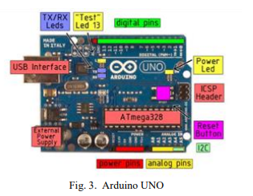

2) Accelerometer sensor

The ADXL335 [8] is a small, thin, low power, complete 3- axis accelerometer with signal conditioned voltage outputs. It has 6 pins. 3 pins are for X, Y, Z axis. First pin for power supply (VCC), second pin for ground (GND) and the last one for selftest (ST). It operates on 3.3V from the Arduino Uno board. X and Y axis pins are connected to A0 and A1 pin of Arduino Uno board correspondingly. It can measure the static acceleration of gravity from tilt sensing applications as well as dynamic acceleration ensuing from motion, shock or vibration and gives corresponding analog values through X, Y, Z axis pins. The ADXL335 is available in a small, low profile, 4mm x 4mm x 1.45 mm, 16-lead, plastic lead frame chip scale package. The low cost and small size of 3-axis accelerometer are the two factors that make it effective to detect the hand gesture [2].

5) RF transmitter and receiver module

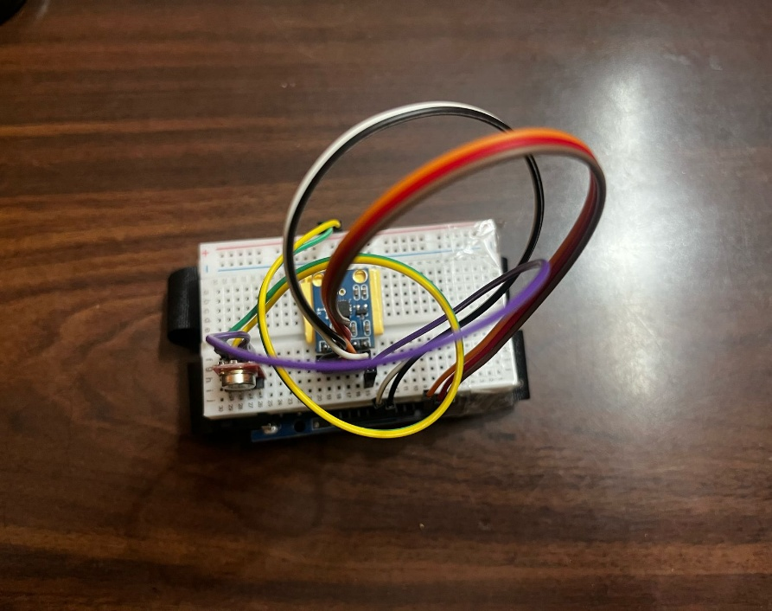 RF stands for radio frequency [11]. It is obtainable completely different in operation frequencies and with different operating range. We have used 433 MHz RF Tx/Rx module. RF module is commonly used along in conjunction with a pair of encoder and decoder. It can transmit the signal up to 500 ft of range at rate of 1 Kbps to 10 Kbps.

6) Motor driver L293D

L293D is a dual H-bridge motor driver integrated circuit (IC). Motor drivers act as current amplifiers since they take a low-current control signal and provide a higher-current signal. This higher current signal is used to drive the motors [12]. L293D contains two inbuilt H-bridge driver circuits. In its common mode of operation, two DC motors can be driven simultaneously, both in forward and reverse direction. The motor operations of two motors can be controlled by input logic at pins 2 & 7 and 10 & 15. Input logic 00 or 11 will stop the corresponding motor. Logic 01 and 10 will rotate it in clockwise and anticlockwise directions, respectively. Enable pins 1 and 9 (corresponding to the two motors) must be high for motors to start operating. When an enable input is high, the associated driver gets enabled. As a result, the outputs become active and work in phase with their inputs. Similarly, when the enable input is low, that driver is disabled, and their outputs are off and in the high-impedance state [12].

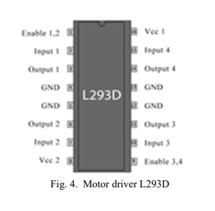

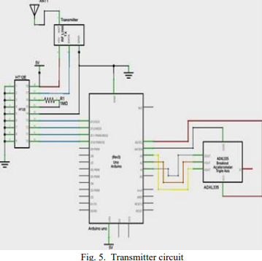**5. Design and working**

Fig 6. Transmitter model

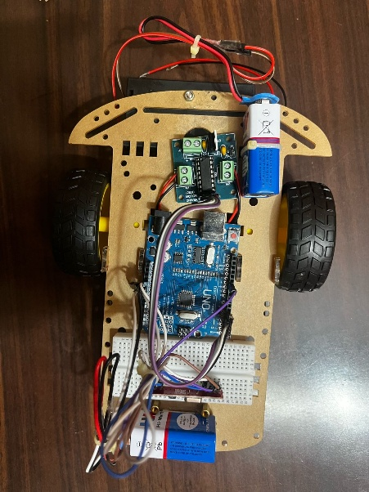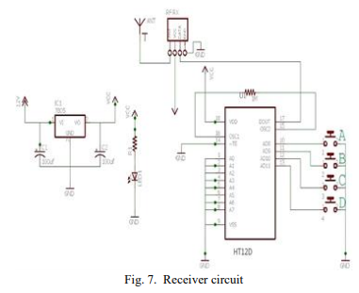

Fig 8. Receiver model

**6. Conclusion**

In this paper, an automated robot has been developed which works according to your hand gesture. The robot moves wirelessly according to palm gesture. The RF module is working on the frequency of 433 MHz and has a range of 50- 80 meters. This robot can be upgraded to detect human life in earthquake and landslide by implementing the sensor accordingly. It can also be upgraded to bomb detecting robot by adding robotic arm which can also lift the bomb as well as in general terms, a robotic arm can be added which can be used in our day to day activities making human life easy.

**References**

[1] Gesture Controlled Robot Using Arduino And Android Premangshu Chanda, Pallab Kanti Mukherjee, Subrata Modak, Asoke Nath Department Of Computer Science, St. Xavier‟S College(Autonomous), Kolkata, West Bengal, India

[2] Accelerometer Based Gesture Controlled Robot Using Arduino Swarnaprabha Jena, Sworaj Kumar Nayak, Saroj Kumar Sahoo, Sibu Ranjan Sahoo, Saraswata Dash, Sunil Kumar Sahoo Electronics And Communication Engineering, Centurion University Of Technology And Management, India

[3] S. Waldherr, R. Romero And S. Thrun, 2000, “A Gesture Based Interface For Human-Robot Interaction”, In Autonomous Robots In Springer, Vol. 9, Issue 2, Pp. 151-173Available At Http://Www.Cs.Cmu.Edu/~Thrun/Papers/Waldherr.GesturesJournal.Pdf

[4] Wang, B., And Yuan, T., “Traffic Police Gesture Recognition Using Accelerometer”, IEEE SENSORS Conference, Lecce-Italy, pp. 1080- 1083,Oct. 2008.

[5] Song, M., Kim, B., Ryu, Y., Kim, Y., And Kim, S., “A Design Of Real Time Control Robot System Using Android Smartphone” The 7th International Conference On Ubiquitous Robots And Ambient Intelligence (URAI), Busan- Korea, Nov. 2010.

[6] <Https://Diyhacking.Com/Hand-Gestures-Robot/>

[7] Shruthi B. N, Shivraj, Sumathi S, “Hand Gesture Based Direction Control Of Robocar Using Arduino Microcontroller”, International Journal Of Recent Technology And Engineering(IJRTE), Volume-3, Issue-3,PP.-32- 35, July 2014.

[8]Http://Www.Analog.Com/Media/En/Technicaldocumentation/DataSheets/ADXL335.Pdf

[9][Http://Www.Holtek.Com/Pdf/Consumer/2_12ev120 .Pdf](Http://Www.Holtek.Com/Pdf/Consumer/2_12ev120%20.Pdf)

[10]Http://Www.Eleinmec.Com/Datasheets/Ds_Holtek_ Ht12d.Pdf

[11] Http://Oap.Sourceforge.Net/Datasheets/Rf.Pdf

[12]Https://Www.Engineersgarage.Com/Electronic-Components/L293dMotor-Driver-Ic